**Chapter 05**

Table of Contents

5.1 2

Integral Method 2

Rectangle Method 4

5.2 Sigma Notation and Limits of Finite Sums 15

5.3 The Definite Integral 16

The Average Value Theorem 16

5.4 The Fundamental Theorem of Calculus 23

Theorem 3: The Mean Value Theorem 23

Theorem 4: The Fundamental Theorem of Calculus (Part 1) 23

Theorem 5: The Fundamental Theorem of Calculus (Part 2) 23

5.5 Substitution Method 30

5.6 Substitution and Area Between Curves 37

## 5.1

- indefinite integral

- definite integral

Definite integral gives the area of space bounded by the curve $y=f\left(x\right)$ with the $x$-axis and the ordinates of the lines $x=a$ and $x=b$.

### Integral Method

$$\int_{1}^{2}{xdx}={\left[\frac{x^{2}}{2}\right]}_{1}^{2}=\frac{3}{2}units^{2}$$



Area of shaded trapezium $=\frac{1}{2}\left(1+2\right)\left(2-1\right)=\frac{3}{2}units^{2}$

$$\int_{0}^{2}{2dx}={\left[2x\right]}_{0}^{2}=4 units^{2}$$



Area of square $=2×2=4 units^{2}$

$$\int_{-2}^{2}{\sqrt{4-x^{2}}dx}$$

Let $x=2\sin{θ}$

$x=2$, $θ=\sin^{-1}{(1)}=\frac{π}{2}$

$x=-2$, $θ=\sin^{-1}{(-1)}=-\frac{π}{2}$

$$dx=2\cos{θ}dθ$$

$$∴\int_{-2}^{2}{\sqrt{4-x^{2}}dx}$$

$$=\int_{-\frac{π}{2}}^{\frac{π}{2}}{\sqrt{4-4\sin^{2}{θ}}⋅2\cos{θ}dθ}$$

$$=4\int_{-\frac{π}{2}}^{\frac{π}{2}}{\sqrt{\cos^{2}{θ}}⋅\cos{θ}dθ}$$

$$=4\int_{-\frac{π}{2}}^{\frac{π}{2}}{\frac{\cos{2θ}+1}{2}dθ}$$

$$=2{\left[\frac{\sin{2θ}}{2}+θ\right]}_{-\frac{π}{2}}^{\frac{π}{2}}$$

$$=2\left[\frac{\sin{π}}{2}+\frac{π}{2}-\frac{\sin{-π}}{2}+\frac{π}{2}\right]$$

$$=2π$$



Area $=\frac{π×2^{2}}{2}=2π$

### Rectangle Method



Let $n$ be the number of rectangles with equal width $∆x$, i.e. $∆x=\frac{b-a}{n}$.

Let $x_{0}=a$, $x_{1}=x_{0}+∆x$, $x_{2}=x_{1}+∆x$ and so on until $x_{n}=x_{n-1}+∆x=b$.

i) Left-Endpoint Approximation (or Lower Sum Approximation)

The area of the 1st rectangle, $A_{1}=f\left(x_{0}\right)⋅∆x$, the second rectangle $A_{2}=f\left(x_{1}\right)⋅∆x$ and so on until the area of the $n$ th rectangle, $A_{n}=f\left(x_{n-1}\right)⋅∆x$.

$∴$ Total area, $A=A_{1}+A_{2}……+A_{n}=\left[f\left(x_{0}\right)+f\left(x_{1}\right)……+f\left(x_{n-1}\right)\right]⋅∆x$

If the number of rectangles $n→∞$, then $∆x→0$.

$$A=\int_{a}^{b}{f\left(x\right)dx}=\lim_{\begin{matrix}n→∞ \\ ∆x→0\end{matrix}}{\sum_{i=0}^{n-1}{f\left(x_{i}\right)}⋅∆x}$$

ii) Right-Endpoint Approximation (or Upper Sum Approximation)

$A_{1}=f\left(x_{1}\right)⋅∆x$, $A_{2}=f\left(x_{2}\right)⋅∆x$ and so on until $A_{n}=f\left(x_{n}\right)⋅∆x$.

$$A=\sum_{i=1}^{n}{f\left(x_{i}\right)}⋅∆x$$

$$A=\int_{a}^{b}{f\left(x\right)dx}=\lim_{\begin{matrix}n→∞ \\ x→0\end{matrix}}{f\left(x_{i}\right)}⋅∆x$$

iii) Midpoint Approximation (or Trapezium Approximation)

This method is slightly more accurate.

$A_{1}=\frac{f\left(x_{0}\right)+f\left(x_{1}\right)}{2}⋅∆x$, $A_{2}=\frac{f\left(x_{1}\right)+f\left(x_{2}\right)}{2}⋅∆x$ and so on until $A_{n}=\frac{f\left(x_{n-1}\right)+f\left(x_{n}\right)}{2}⋅∆x$.

$$A=\left[\frac{f\left(x_{0}\right)}{2}+f\left(x_{1}\right)……+f\left(x_{n-1}\right)+\frac{f\left(x_{n}\right)}{2}\right]⋅∆x$$

$$A=\int_{a}^{b}{f\left(x\right)dx}=\lim_{\begin{matrix}n→∞ \\ x→0\end{matrix}}\left[\sum_{i=1}^{n-1}{f\left(x_{i}\right)}+\frac{f\left(x_{0}\right)+f\left(x_{n}\right)}{2}\right]⋅∆x$$

Possible Question: Explain that the definite integral can be written as the limit of finite sum.

The answer is to show the 3 types of approximations above. Only the first one must be shown in detail.

Percentage Error (P.E.)

Let $\int_{a}^{b}{f\left(x\right)dx}=E$ be the exact result.

P.E. $=\left|\frac{E-A}{E}\right|×100\%$

Possible Question: Compare and comment on the results.

The answer is to calculate the percentage error for each of the three approximation methods and show which one gives the least error.

Find the area of the region bounded by the curve $y=2-x^{2}$ above the $x$-axis in the interval $\left[0, 1\right]$, by considering $n=4$, using different approximations. Finally, compare your results with the true value and comment on it.



Here, $y=f\left(x\right)=2-x^{2}$, and the interval is $\left[0, 1\right]$.

$∴a=0$ and $b=1$

True Value, $E=\int_{0}^{1}{f\left(x\right)dx}=\int_{0}^{1}{\left(2-x^{2}\right)dx}$

$$={\left[2x-\frac{x^{3}}{2}\right]}_{0}^{1}$$

$$=2\left(1\right)-\frac{1^{3}}{3}-0+0$$

$$=\frac{5}{3} units^{2}$$

Let the standard region be divided into $n=4$ rectangles, each of equal width $∆x$, where

$$∆x=\frac{b-a}{n}=\frac{1-0}{4}=\frac{1}{4} units$$

$x_{0}=a=0$ $f\left(x_{0}\right)=2-0^{2}=2$

$x_{1}=x_{0}+∆x=0+0.25=0.25$ $f\left(x_{1}\right)=2-{0.25}^{2}=\frac{31}{16}$

$x_{2}=x_{1}+∆x=0.25+0.25=0.50$ $f\left(x_{2}\right)=2-{0.50}^{2}=\frac{7}{4}$

$x_{3}=x_{2}+∆x=0.50+0.25=0.75$ $f\left(x_{3}\right)=2-{0.75}^{2}=\frac{23}{16}$

$x_{4}=x_{3}+∆x=0.75+0.25=1.00$ $f\left(x_{4}\right)=2-1^{2}=1$

M-1: Left-Endpoint Approximation

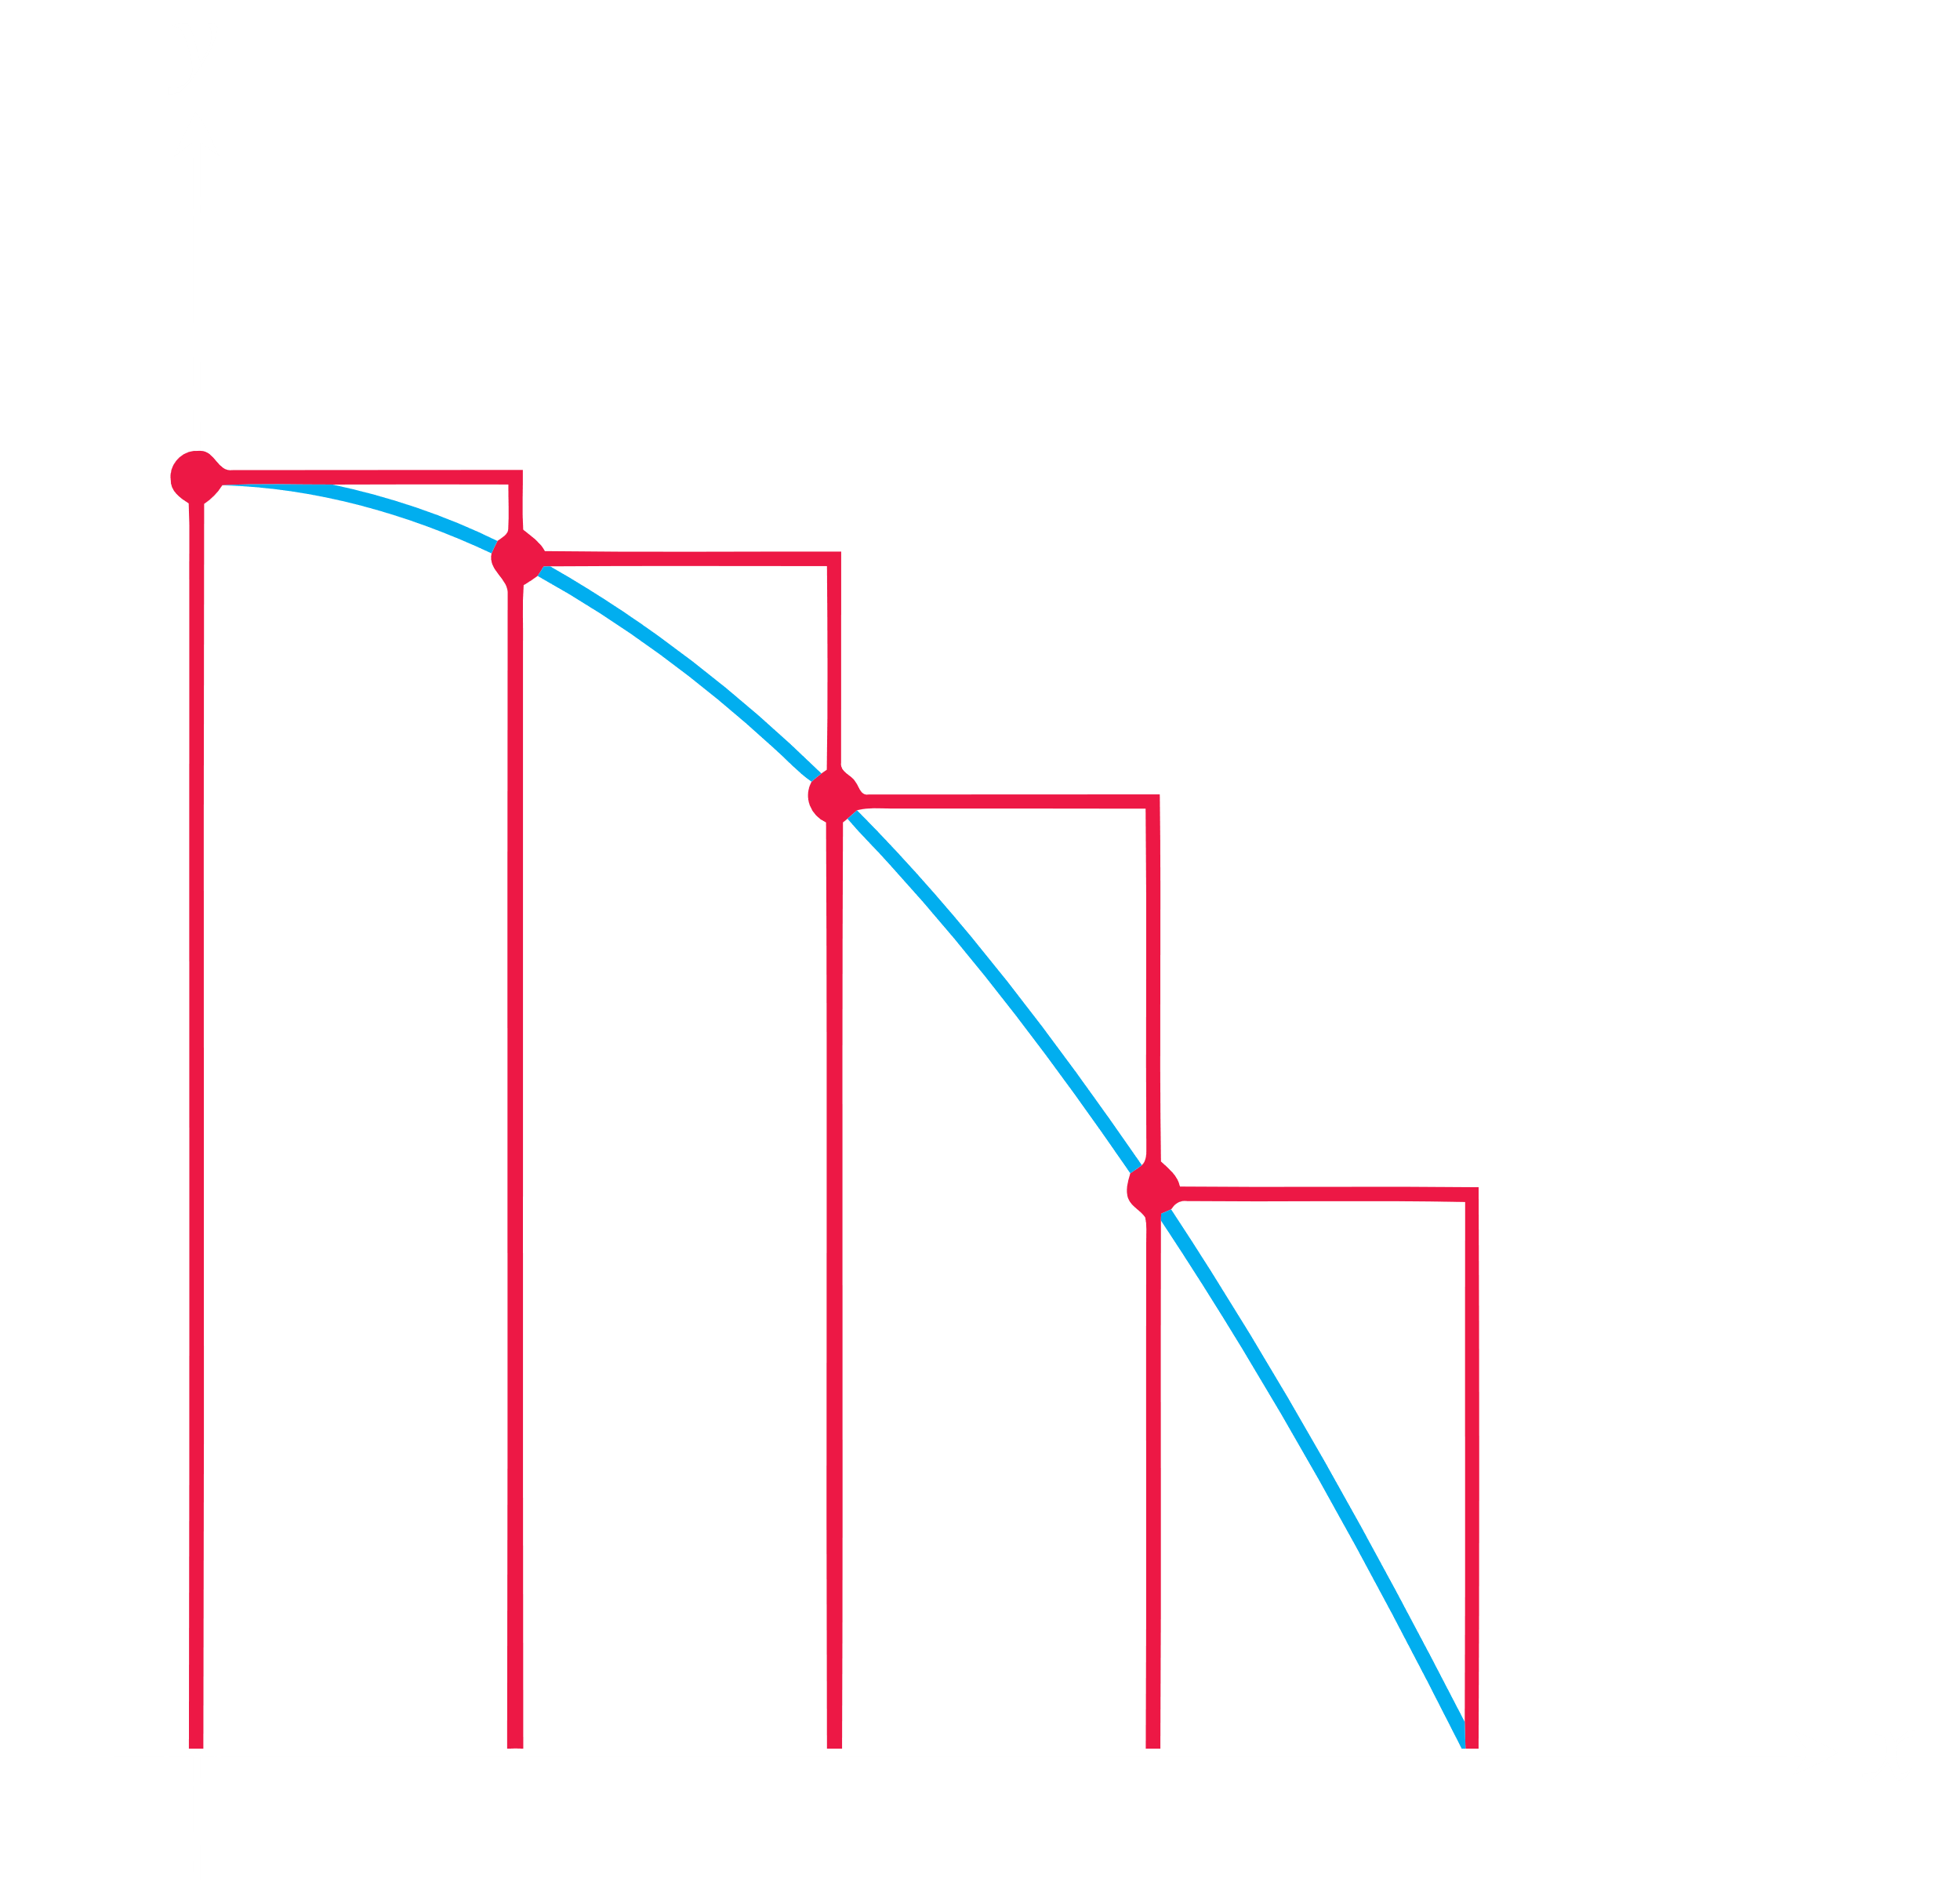

By definition, we know area

$$A=\sum_{i=0}^{n-1}{f\left(x_{i}\right)}⋅∆x=\sum_{i=0}^{3}{f\left(x_{i}\right)}⋅∆x$$

$$=∆x\left[f\left(x_{0}\right)+f\left(x_{1}\right)+f\left(x_{2}\right)+f\left(x_{3}\right)\right]$$

$$=0.25\left[2+\frac{31}{16}+\frac{7}{4}+\frac{23}{16}\right]$$

$$=\frac{57}{32} units^{2}$$

M-2: Right-Endpoint Approximation

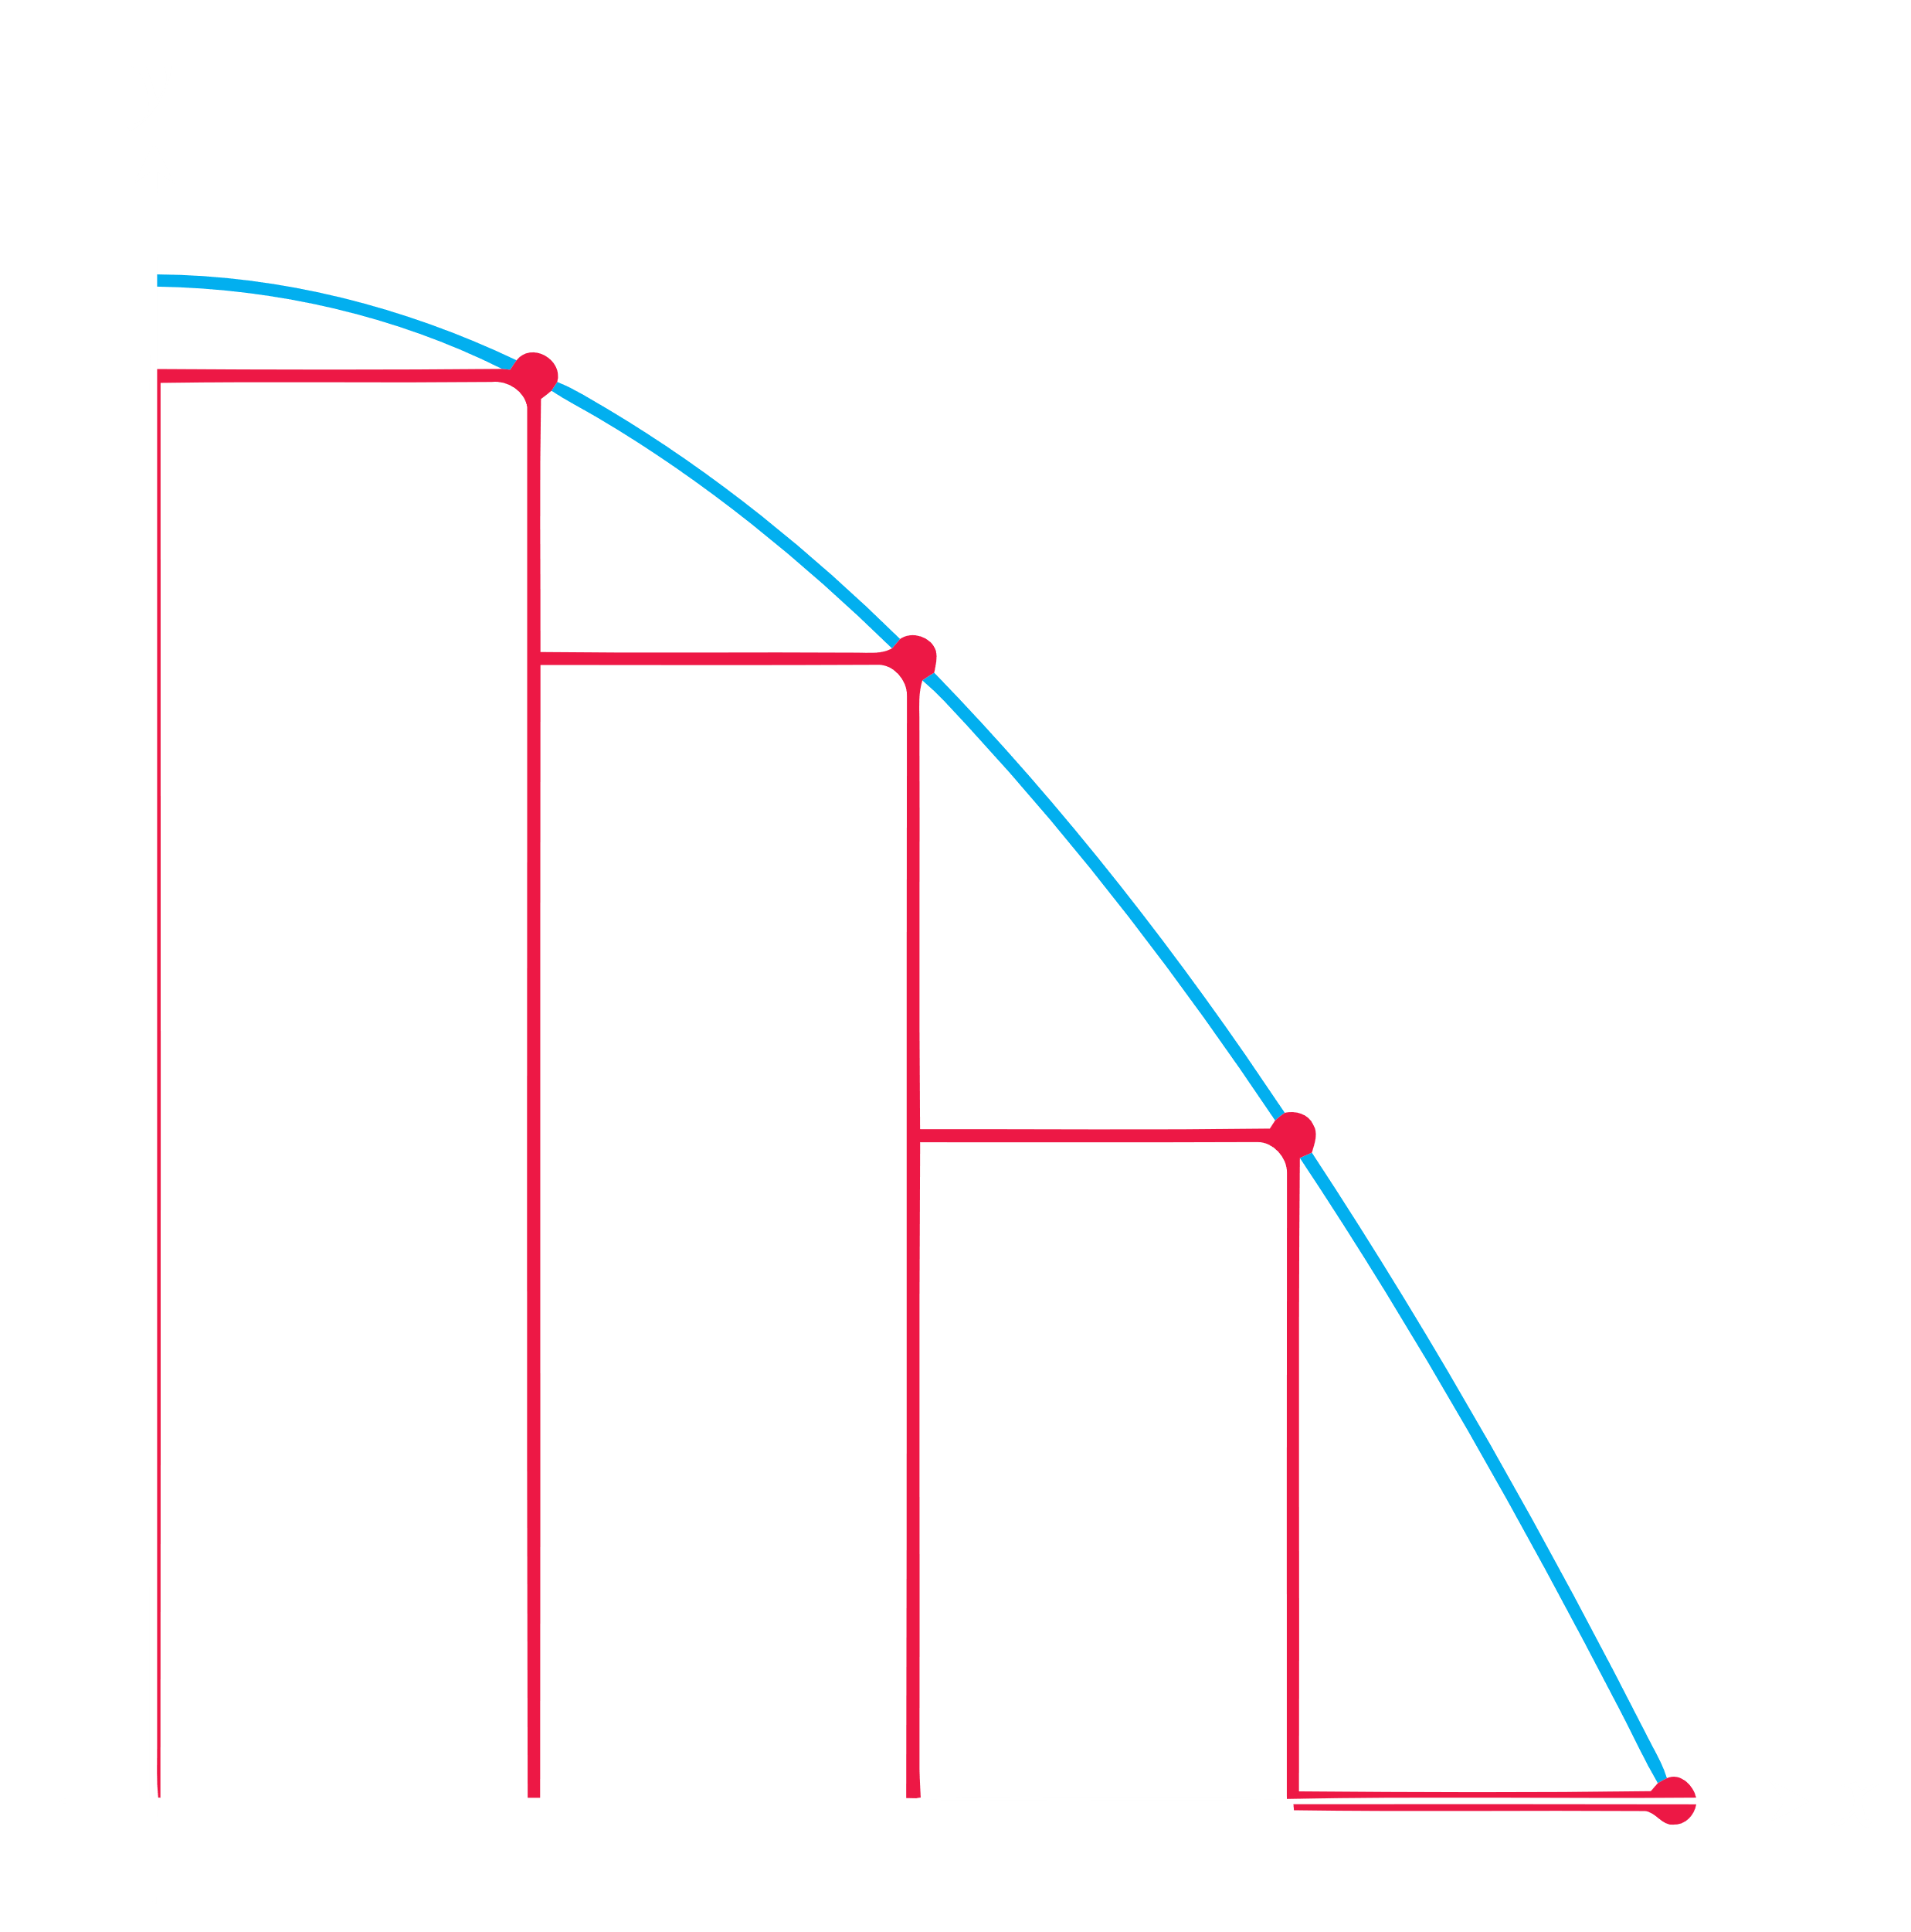

By definition, we know area

$$A=\sum_{i=1}^{n}{f\left(x_{i}\right)}⋅∆x=\sum_{i=1}^{4}{f\left(x_{i}\right)}⋅∆x$$

$$=∆x\left[f\left(x_{1}\right)+f\left(x_{2}\right)+f\left(x_{3}\right)+f\left(x_{4}\right)\right]$$

$$=0.25\left[\frac{31}{16}+\frac{7}{4}+\frac{23}{16}+1\right]$$

$$=\frac{49}{32} units^{2}$$

M-3: Mid-Point Approximation

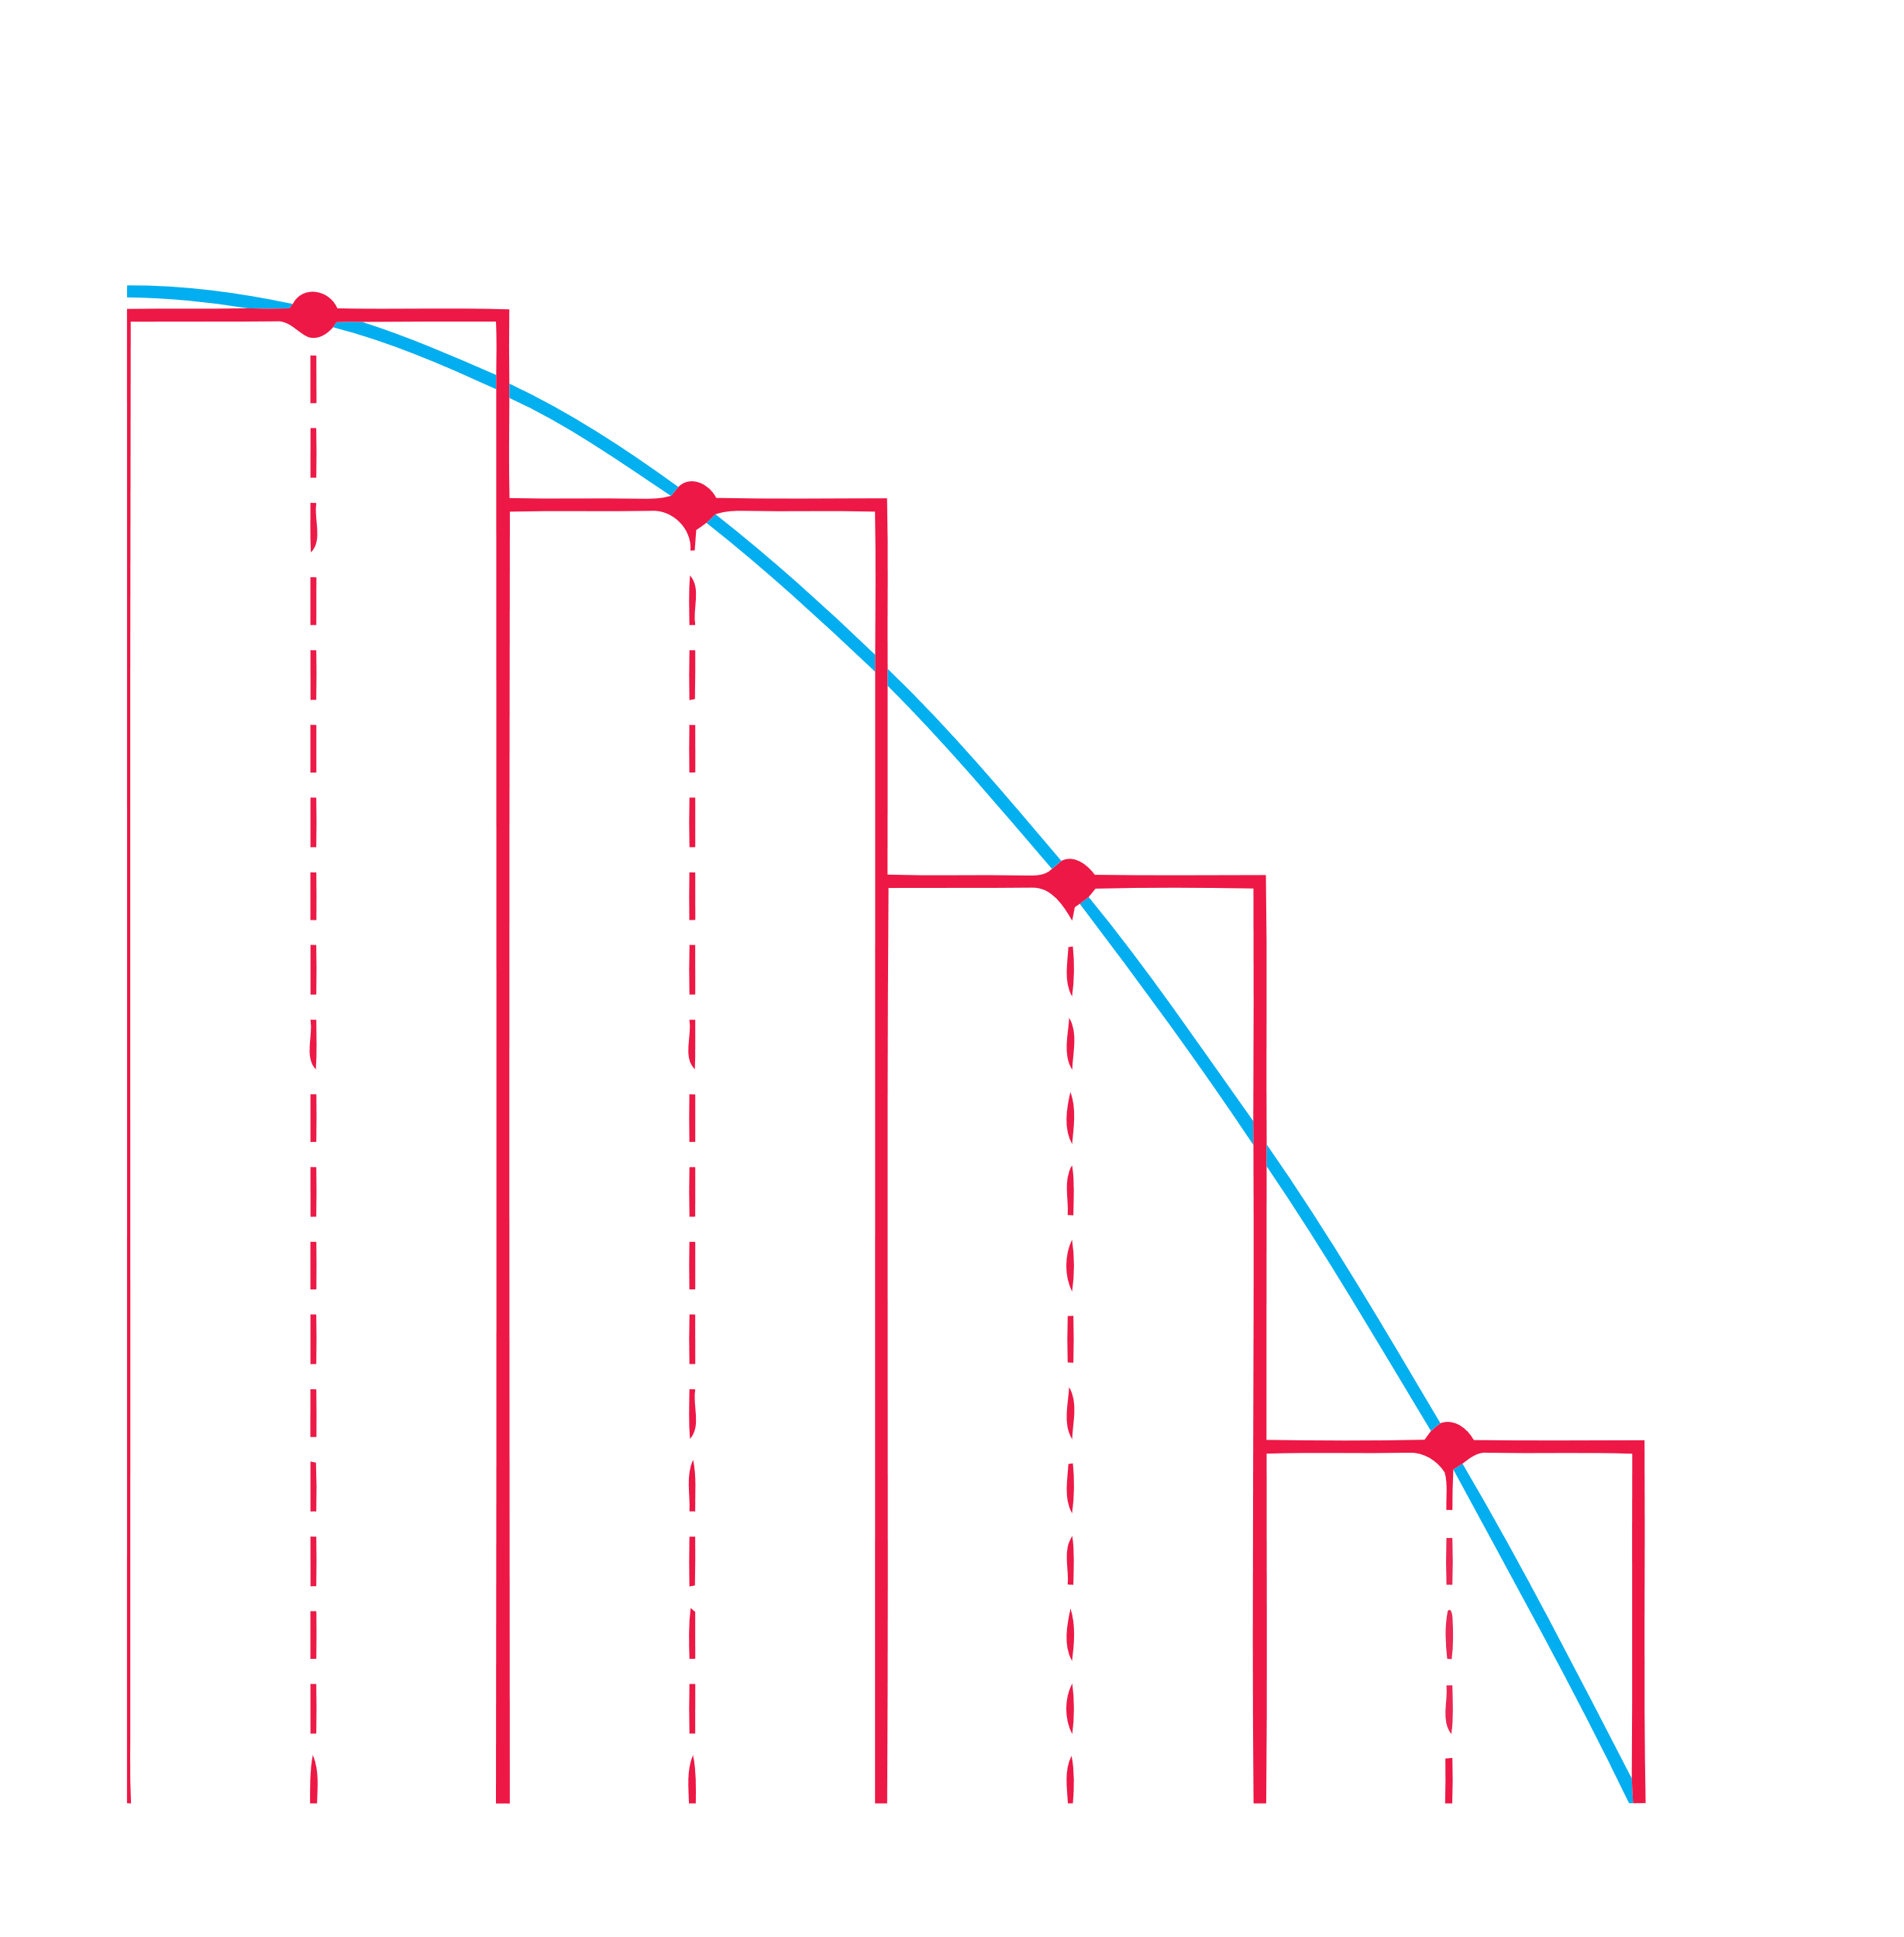

By definition, we know area

$$A=\left[\frac{f\left(x_{0}\right)+f\left(x_{4}\right)}{2}+f\left(x_{1}\right)+f\left(x_{2}\right)+f\left(x_{3}\right)\right]⋅∆x$$

$$=\left(\frac{2+1}{2}+\frac{31}{16}+\frac{7}{4}+\frac{23}{16}\right)×0.25$$

$$=\frac{53}{32} units^{2}$$

Percentage Error

For M-1: P.E. $=\left|\frac{E-A}{E}\right|×100\%=\left|\frac{\frac{5}{3}-\frac{57}{32}}{\frac{5}{3}}\right|×100\%=6.875\%$

For M-2: P.E. $=\left|\frac{E-A}{E}\right|×100\%=\left|\frac{\frac{5}{3}-\frac{49}{32}}{\frac{5}{3}}\right|×100\%=8.125\%$

For M-3: P.E. $=\left|\frac{E-A}{E}\right|×100\%=\left|\frac{\frac{5}{3}-\frac{53}{32}}{\frac{5}{3}}\right|×100\%=0.625\%$

From the above, it is seen that mid-point approximation is the best approximation method among the three, since it gives the least error.

If the question states more than 1 value of $n$, the process must be repeated for each value of $n$. Only the comment at the end will be different.

Say $n=4$ and $n=8$.

Comment:

For every method, error is less for $n=8$, meaning increasing the number of rectangles decreases error. For both values of $n$, the mid-point approximation method gives the least error amongst the three methods.

Exercise 19

Oil is leaking out of a tanker damaged at sea. The damage to the tanker is worsening as evidenced by increased leakage each hour, recorded in the following table:

|  |  |  |  |  |  |  |  |  |  |
| --- | --- | --- | --- | --- | --- | --- | --- | --- | --- |
| Time (hours) | $$0$$ | $$1$$ | $$2$$ | $$3$$ | $$4$$ | $$5$$ | $$6$$ | $$7$$ | $$8$$ |
| Leakage (gallons/hours) | $$50$$ | $$70$$ | $$97$$ | $$136$$ | $$190$$ | $$265$$ | $$369$$ | $$516$$ | $$720$$ |

a) Give an upper and a lower estimate of the total quantity of oil that has escaped after 5 hours.

b) Repeat part (a) for the quantity of oil that has escaped after 8 hours.

c) The tanker continues to leak 720 gal/h after the first 8 hours. If the tanker originally contained 25,000 gallons of oil, approximately how many more hours will elapse in the best case and in the worst case before all of the oil is spilled?

Since the amount is increasing, the right-end approximation will give the upper estimate and the left-end approximation will give the lower estimate.

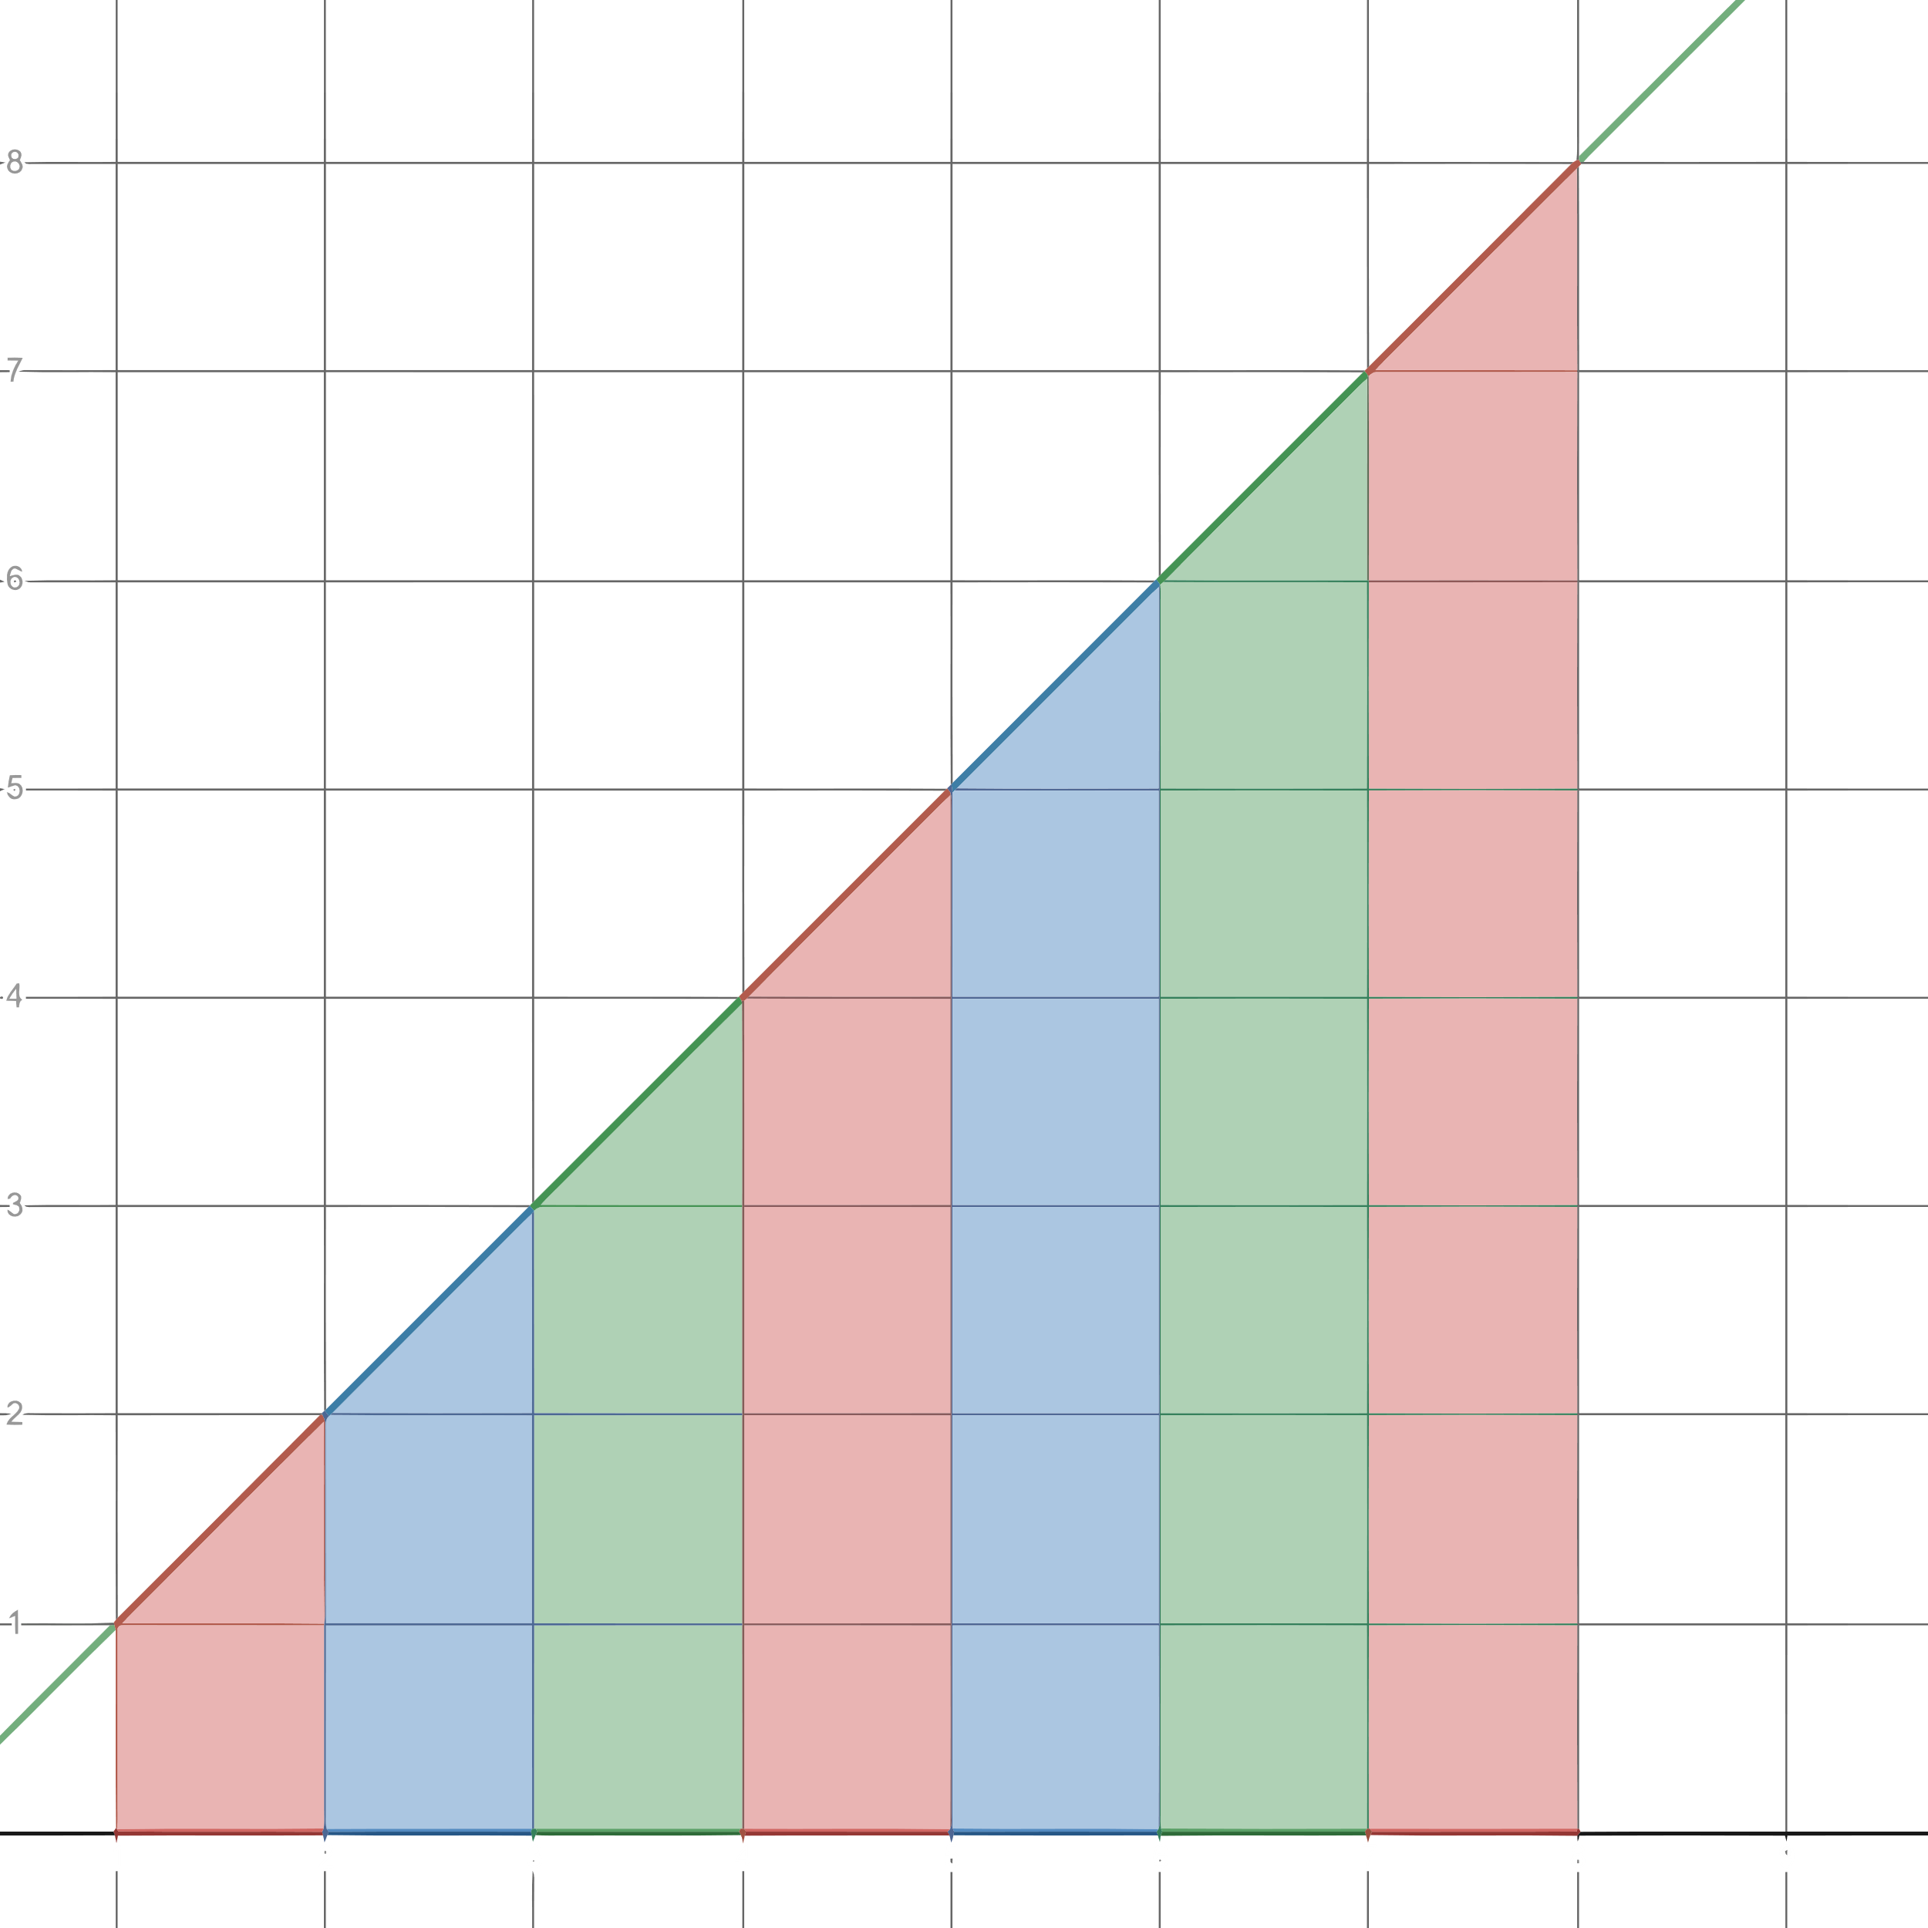

Here, $∆x=1$

$x_{0}=0$ $f\left(x_{0}\right)=50$

$x_{1}=1$ $f\left(x_{1}\right)=70$

$x_{2}=2$ $f\left(x_{2}\right)=97$

$x_{3}=3$ $f\left(x_{3}\right)=136$

$x_{4}=4$ $f\left(x_{4}\right)=190$

$x_{5}=5$ $f\left(x_{5}\right)=265$

$x_{6}=6$ $f\left(x_{6}\right)=369$

$x_{7}=7$ $f\left(x_{7}\right)=516$

$x_{8}=8$ $f\left(x_{8}\right)=720$

$$n=\frac{b-a}{∆x}=\frac{8-0}{1}=8$$

a) For the first 5 hours,

Upper Estimate:

By definition we know the area

$$A=\sum_{i=1}^{n}{f(x_{i})}⋅∆x$$

$$=\sum_{i=1}^{5}{f(x_{i})}⋅∆x$$

$$=\left[f\left(x_{1}\right)+f\left(x_{2}\right)+f\left(x_{3}\right)+f\left(x_{4}\right)+f\left(x_{5}\right)\right]×∆x$$

$$=\left(70+97+136+190+265\right)×1$$

$$=758 gallons$$

Lower Estimate:

By definition we know the area,

$$A=\sum_{i=0}^{n-1}{f(x_{i})}⋅∆x$$

$$=\sum_{i=0}^{4}{f(x_{i})}⋅∆x$$

$$=\left[f\left(x_{0}\right)+f\left(x_{1}\right)+f\left(x_{2}\right)+f\left(x_{3}\right)+f\left(x_{4}\right)\right]×∆x$$

$$=\left(50+70+97+136+190\right)×1$$

$$=643 gallons$$

b) For the first 8 hours,

Upper Estimate:

By definition we know the area,

$$A=\sum_{i=1}^{n}{f(x_{i})}⋅∆x$$

$$=\sum_{i=1}^{8}{f(x_{i})}⋅∆x$$

$$=\left[f\left(x_{1}\right)+f\left(x_{2}\right)+f\left(x_{3}\right)+f\left(x_{4}\right)+f\left(x_{5}\right)+f\left(x_{6}\right)+f\left(x_{7}\right)+f\left(x_{8}\right)\right]×∆x$$

$$=\left(70+97+136+190+265+369+516+720\right)×1$$

$$=2363 gallons$$

Lower Estimate:

By definition we know that area,

$$A=\sum_{i=0}^{n-1}{f(x_{i})}⋅∆x$$

$$=\sum_{i=0}^{7}{f(x_{i})}⋅∆x$$

$$=\left[f\left(x_{0}\right)+f\left(x_{1}\right)+f\left(x_{2}\right)+f\left(x_{3}\right)+f\left(x_{4}\right)+f\left(x_{5}\right)+f\left(x_{6}\right)+f\left(x_{7}\right)\right]×∆x$$

$$=\left(50+70+97+136+190+265+369+516\right)×1$$

$$=1693 gallons$$

c) Let $t$ be the time.

For lower estimate, $25000=1693+720t$

$$t=\frac{25000-1693}{720}=32.4 hours$$

For upper estimate, $25000=2363+720t$

$$t=\frac{25000-2363}{720}=31.4 hours$$

In the worst case, $31.4$ more hours are needed.

In the best case, $32.4$ more hours are needed.

## 5.2 Sigma Notation and Limits of Finite Sums

Sigma Notation

$$\sum_{i=0}^{n}{f(x_{i})}$$

This is used in Riemen’s Sums.

## 5.3 The Definite Integral

Properties:

$$\int_{a}^{b}{f\left(x\right)dx}=-\int_{b}^{a}{f\left(x\right)dx}$$

$$\int_{a}^{a}{f\left(x\right)dx}=0$$

$$\int_{a}^{b}{kf(x)dx}=k\int_{a}^{b}{f\left(x\right)dx}$$

$$\int_{a}^{b}{f\left(x\right)dx}=\int_{a}^{c}{f\left(x\right)dx}+\int_{c}^{b}{f\left(x\right)dx}$$

$$\int_{a}^{b}{f\left(x\right)dx}=\int_{c}^{d}{f\left(z\right)dz}$$

### The Average Value Theorem

If $f$ is integrable on $\left[a, b\right]$, then its average value on $\left[a, b\right]$, also called its mean, is

$$av\left(f\right)=f_{av}=\frac{1}{b-a}\int_{a}^{b}{f\left(x\right)dx}$$

The result will be a value of $y$.

Exercise 5:

Find the average value of $f\left(x\right)=\sqrt{4-x^{2}}$ on $\left[-2, 2\right]$.

Let $x=2\sin{θ}$.

$$∴dx=2\cos{θ}dθ$$

$x=2$, $θ=\frac{π}{2}$

$x=-2$, $θ=-\frac{π}{2}$

$$∴f_{av}=\frac{1}{2+2}\int_{-\frac{π}{2}}^{\frac{π}{2}}{\sqrt{4-4\sin^{2}{θ}}}⋅2\cos{θ}dθ$$

$$=\frac{2}{4}\int_{-\frac{π}{2}}^{\frac{π}{2}}{2\sqrt{1-\sin^{2}{θ}}⋅\cos{θ}dθ}$$

$$=\frac{4}{4}\int_{-\frac{π}{2}}^{\frac{π}{2}}{\sqrt{\cos^{2}{θ}}⋅\cos{θ}dθ}$$

$$=\int_{-\frac{π}{2}}^{\frac{π}{2}}{\cos{θ}⋅\cos{θ}dθ}$$

$$=\int_{-\frac{π}{2}}^{\frac{π}{2}}{\cos^{2}{θ}dθ}$$

$$=\int_{-\frac{π}{2}}^{\frac{π}{2}}{\frac{1+\cos{2θ}}{2}dθ}$$

$$={\left[\frac{1}{2}θ+\frac{\sin{2θ}}{4}\right]}_{-\frac{π}{2}}^{\frac{π}{2}}$$

$$=\left(\frac{1}{2}⋅\frac{π}{2}+\frac{\sin\left(2⋅\frac{π}{2}\right)}{4}+\frac{1}{2}⋅\frac{π}{2}-\frac{\sin\left(2⋅-\frac{π}{2}\right)}{4}\right)$$

$$=\frac{π}{4}+0+\frac{π}{4}-0$$

$$=\frac{π}{2}$$

Exercise 10:

$\int_{1}^{9}{f\left(x\right)dx}=-1$ $\int_{7}^{9}{f\left(x\right)dx}=5$ $\int_{7}^{9}{h\left(x\right)dx}=4$

Find $\int_{7}^{9}{\left[f\left(x\right)+h\left(x\right)\right]dx}$.

$$\int_{7}^{9}{\left[f\left(x\right)+h\left(x\right)\right]dx}=\int_{7}^{9}{f\left(x\right)dx}+\int_{7}^{9}{h\left(x\right)dx}=5+4=9$$

Exercise 15 – 28:

Graph the integrands and use areas to evaluate the integrals.

Exercise 16:

$$\int_{\frac{1}{2} }^{\frac{3}{2}}{\left(-2x+4\right)dx}$$

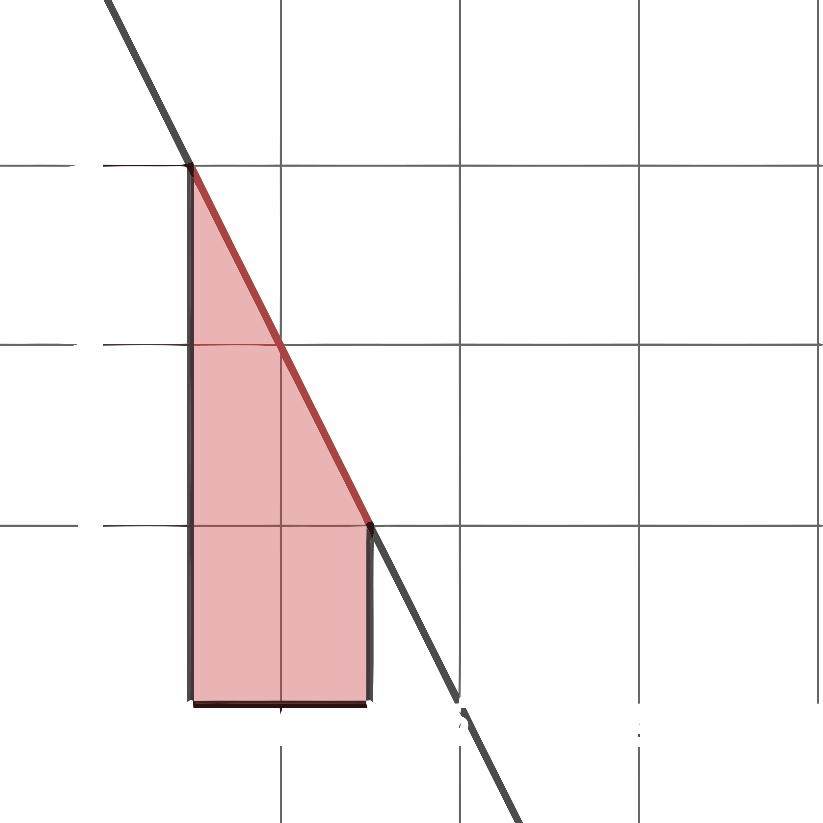

Integrand = $y=-2x+4$.

$y=0$, $x=2$

$x=\frac{1}{2}$, $y=3$

$x=\frac{3}{2}$, $y=1$

Area = Area of Trapezium $ABCD$ = $\frac{1}{2}×\left(AD+BC\right)×AB=\frac{1}{2}\left(3+1\right)\left(\frac{3}{2}-\frac{1}{2}\right)=2 units^{2}$

Exercise 18:

$$\int_{-4}^{0}{\sqrt{16-x^{2}}dx}$$

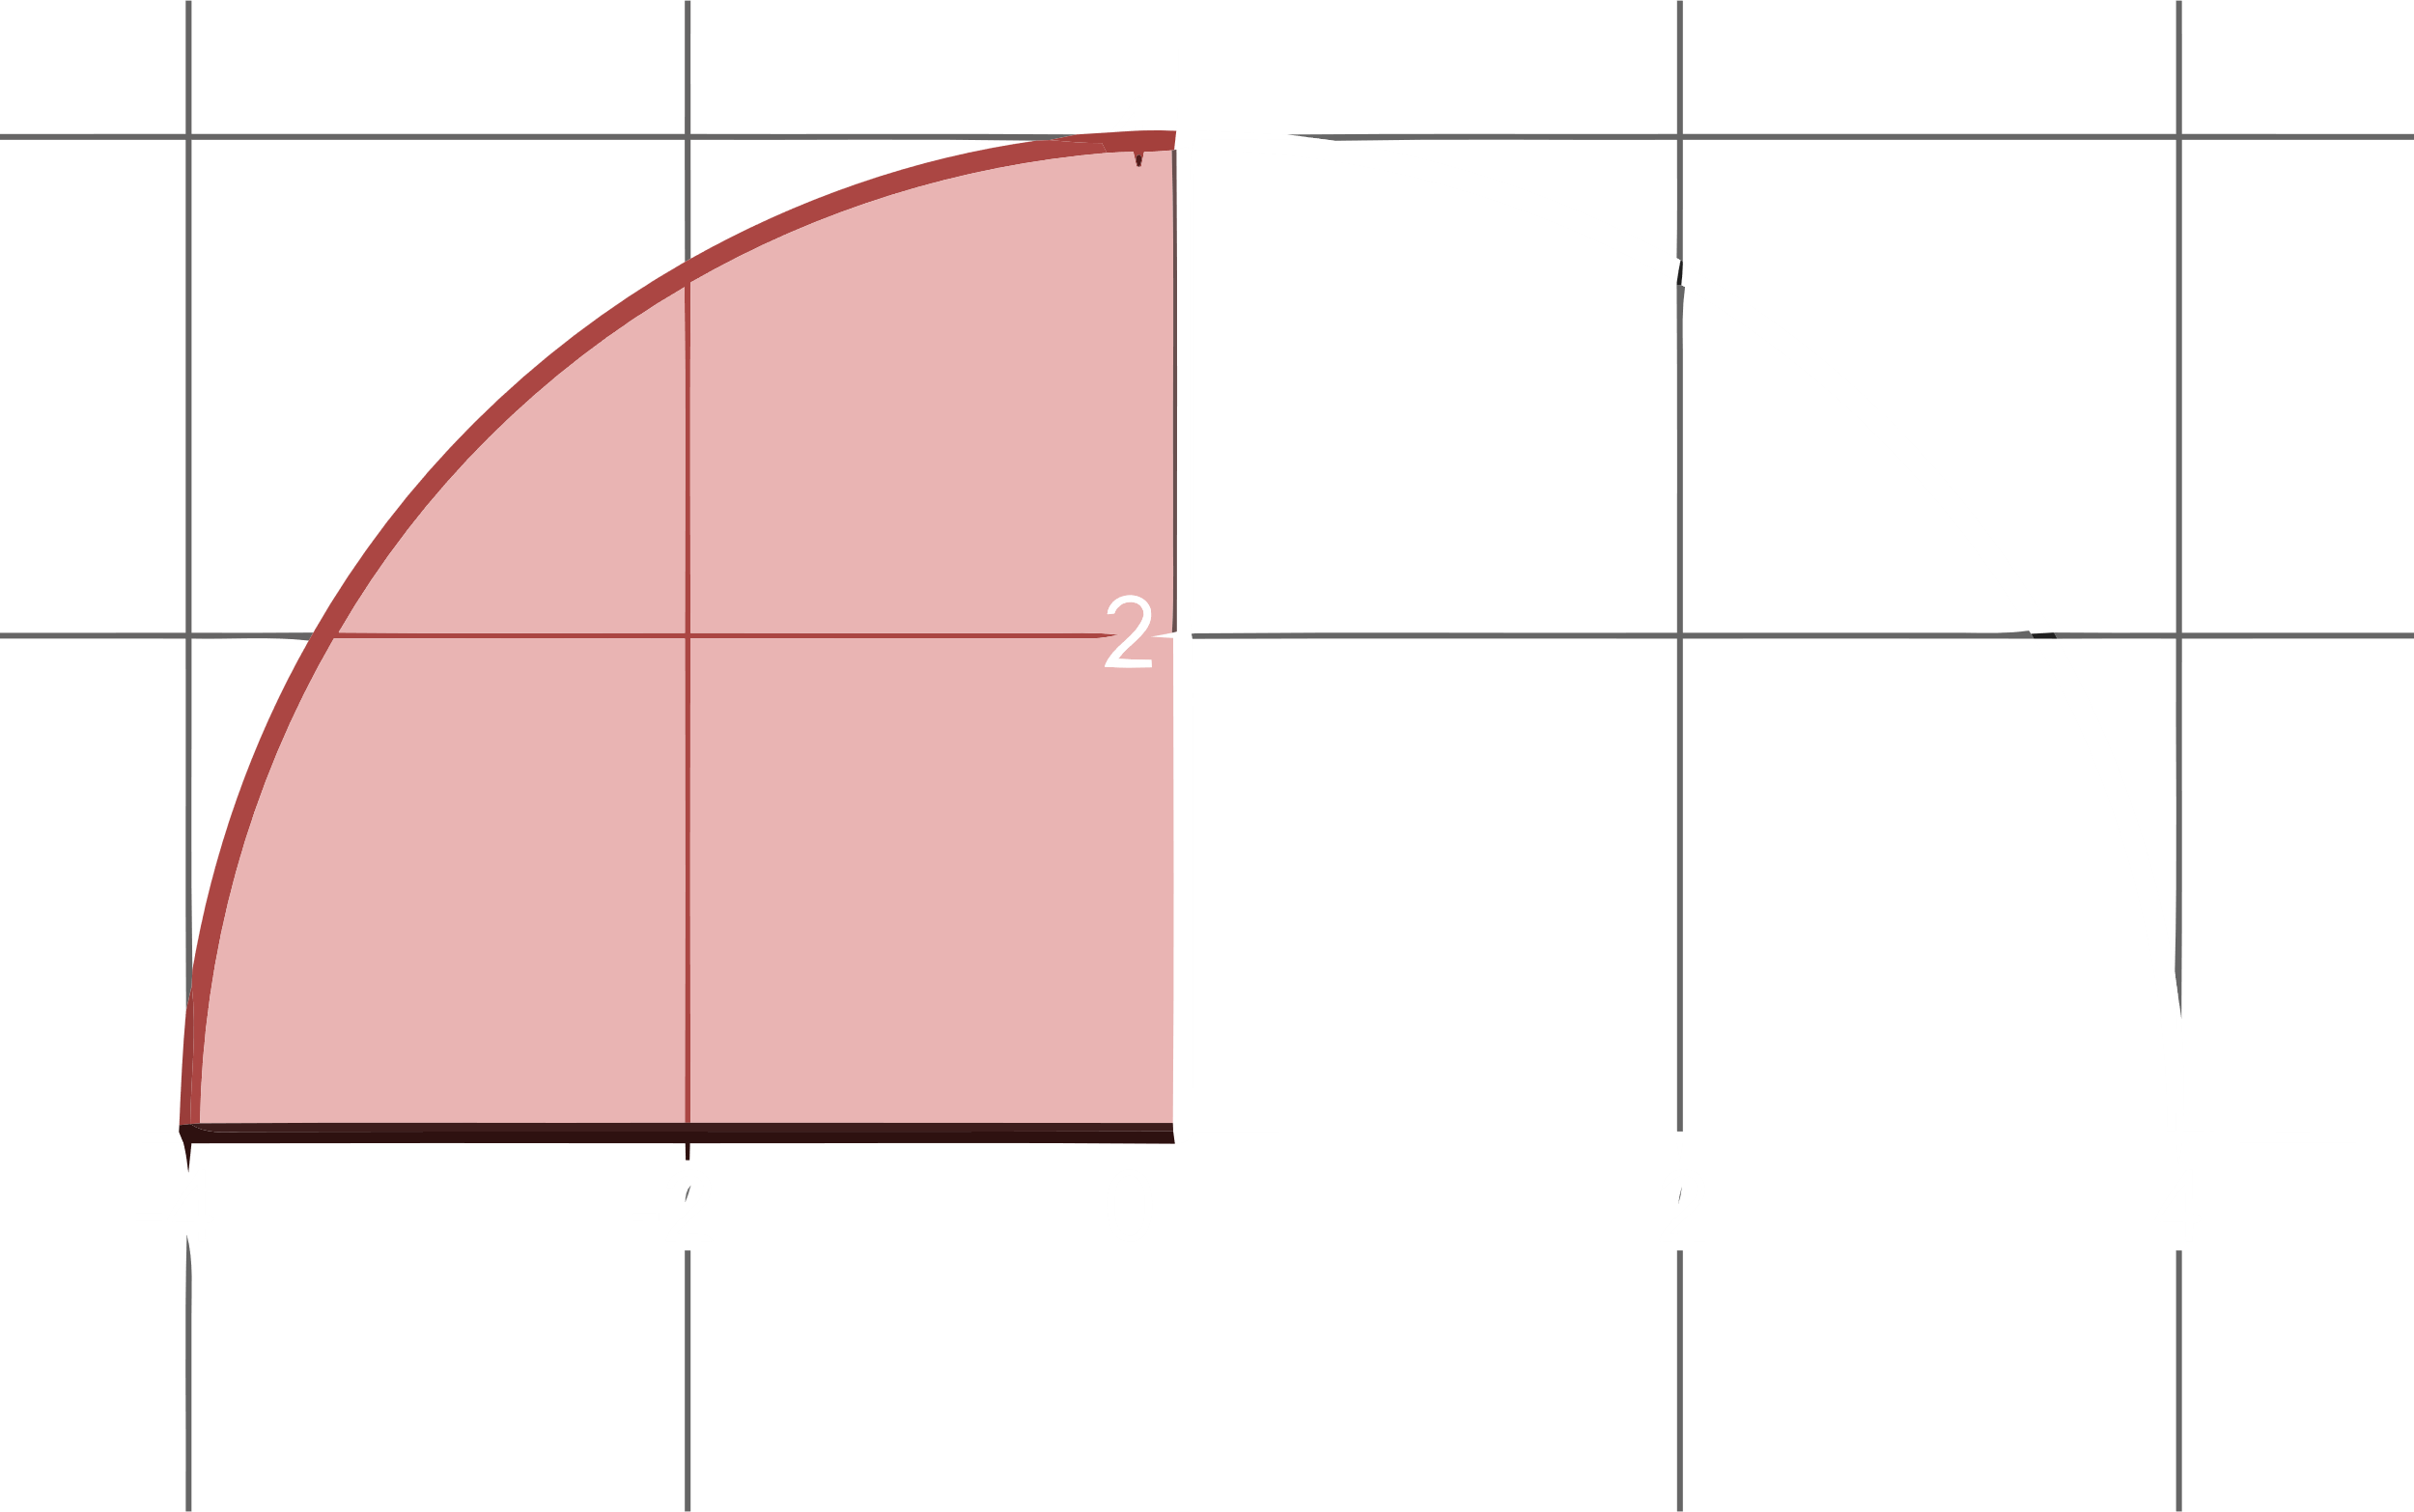

Integrand = $y=\sqrt{16-x^{2}}$

$$y^{2}+x^{2}=4^{2}$$

Radius = $4$

Area = $\frac{1}{4}×π×4^{2}=4π units^{2}$

Exercise 19:

$$\int_{-2}^{1}{\left|x\right|dx}$$

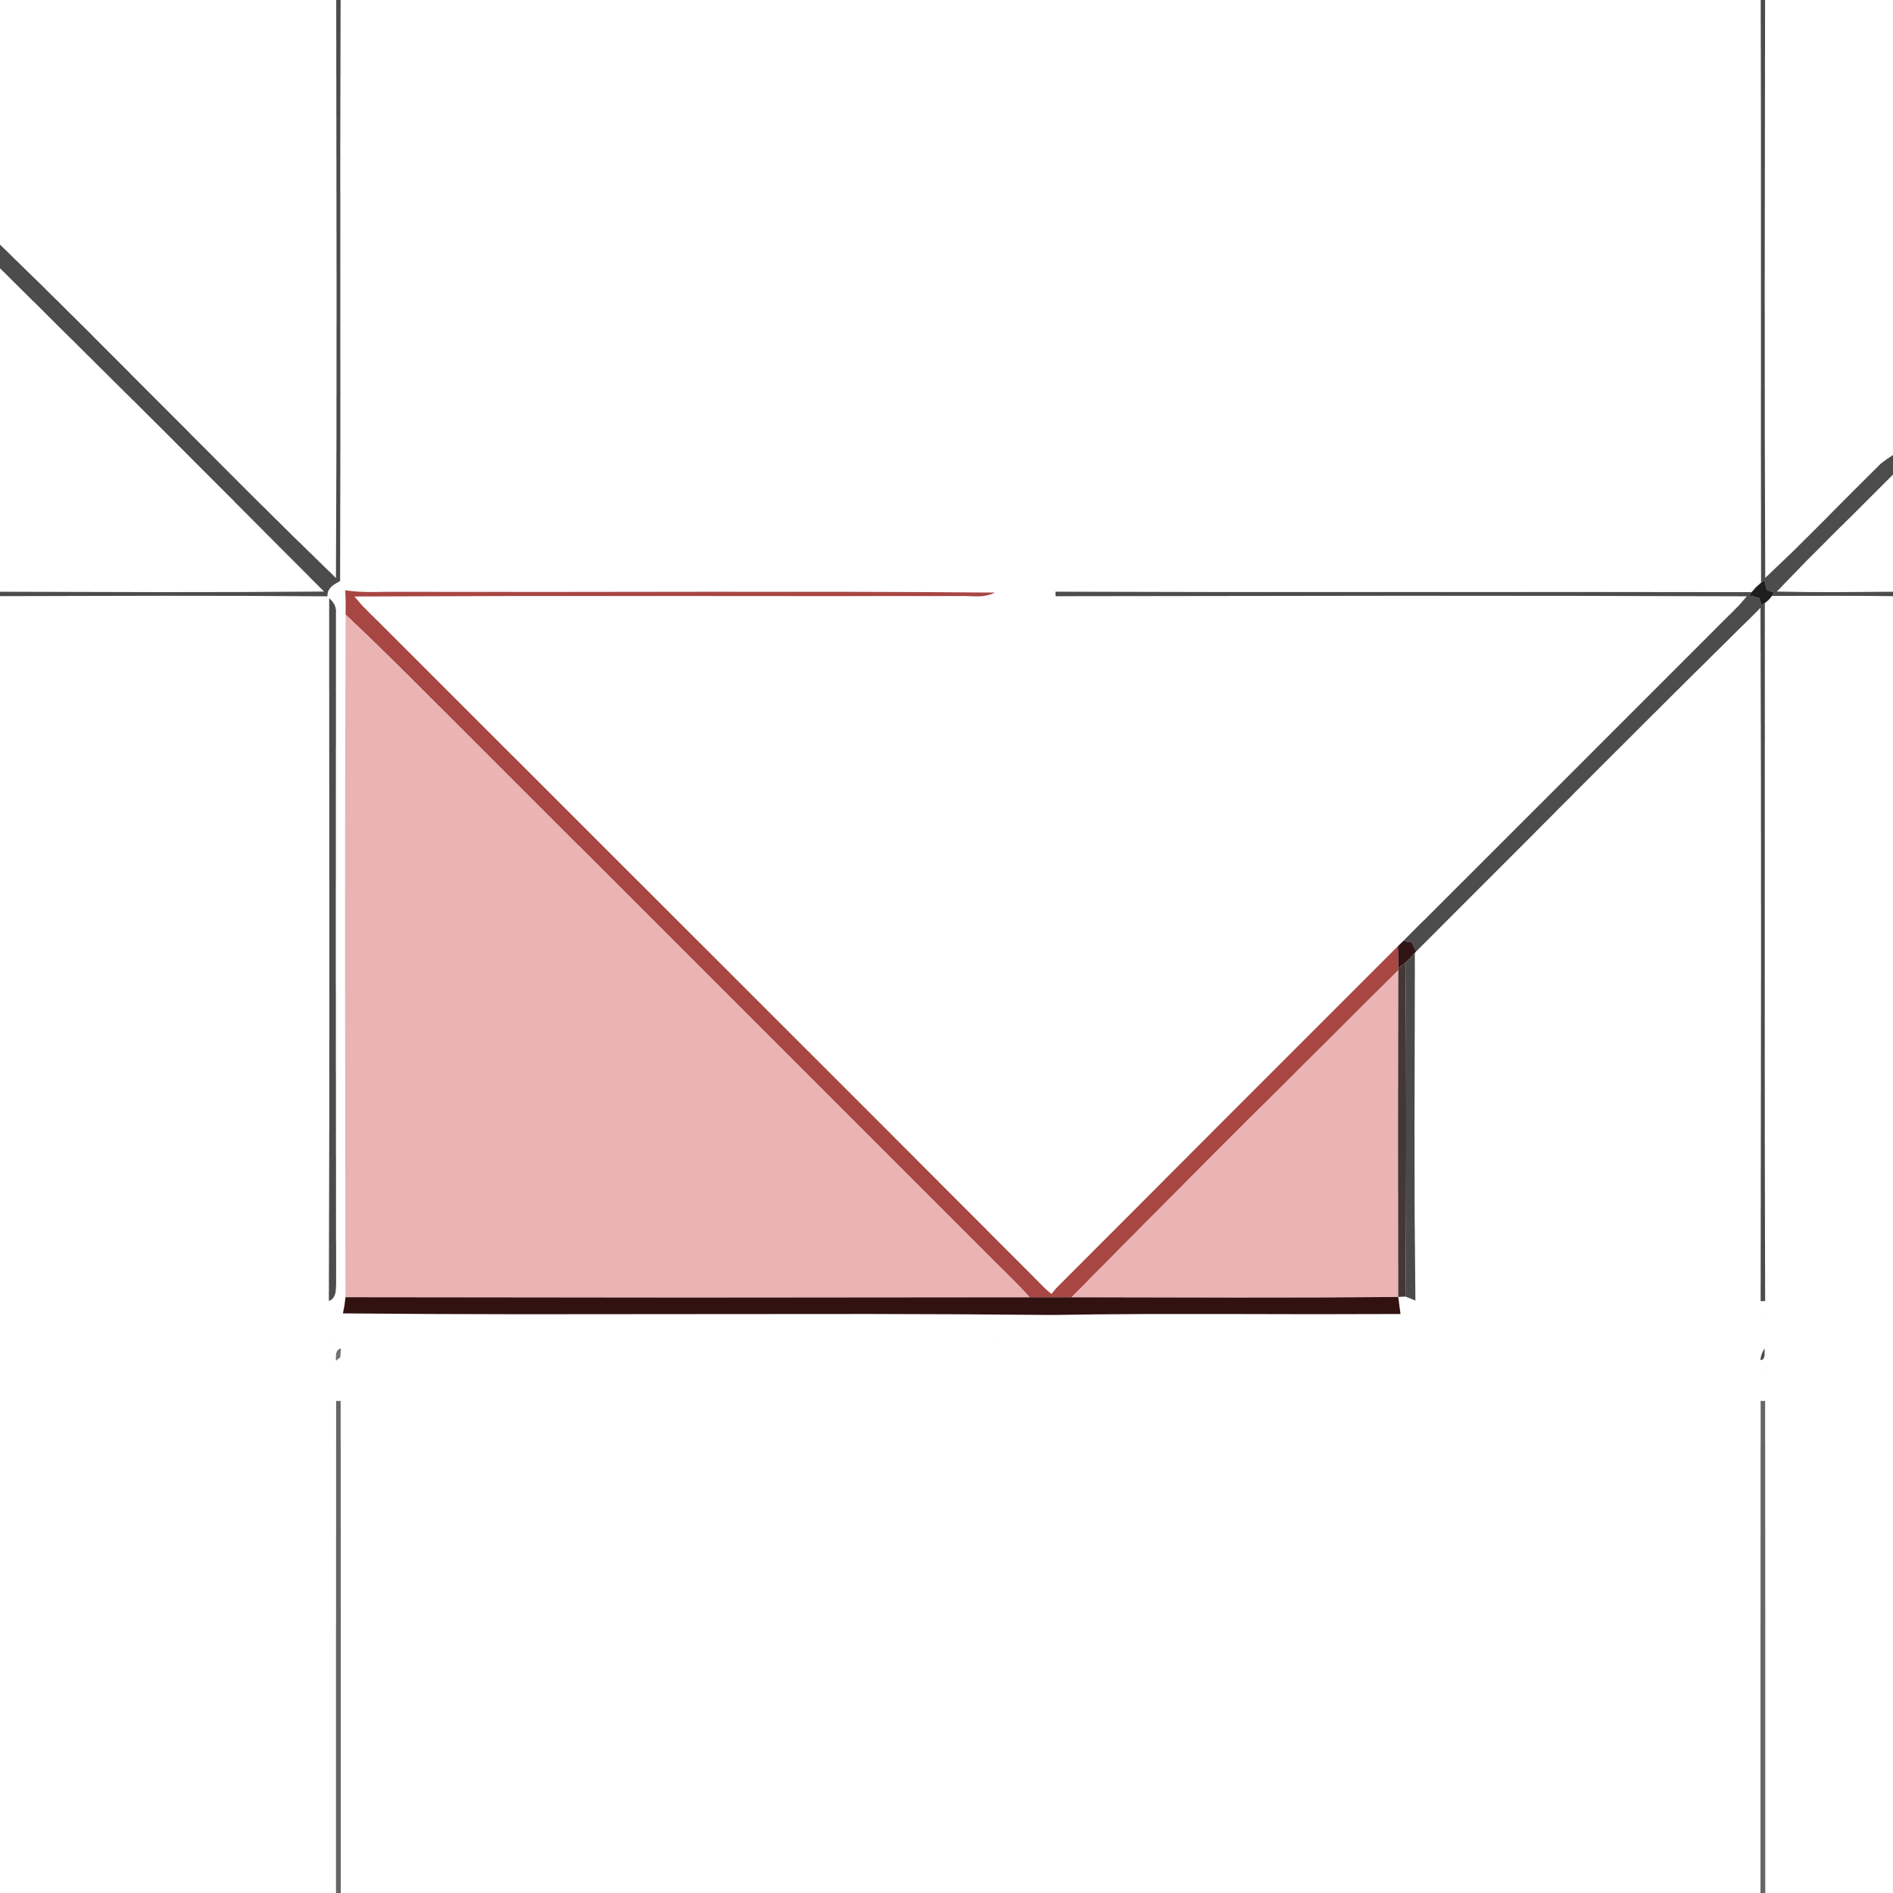

Integrand = $y=\left|x\right|=\left\{\begin{matrix}x & x>0 \\ -x & x≤0\end{matrix}\right.$

$x=1$ $y=1$

$x=-2$ $y=2$

Area = $\left(\frac{1}{2}×2×2\right)+\left(\frac{1}{2}×1×1\right)=2.5 units^{2}$

Exercise 20:

$$\int_{-1}^{1}{\left(1-\left|x\right|\right)dx}$$

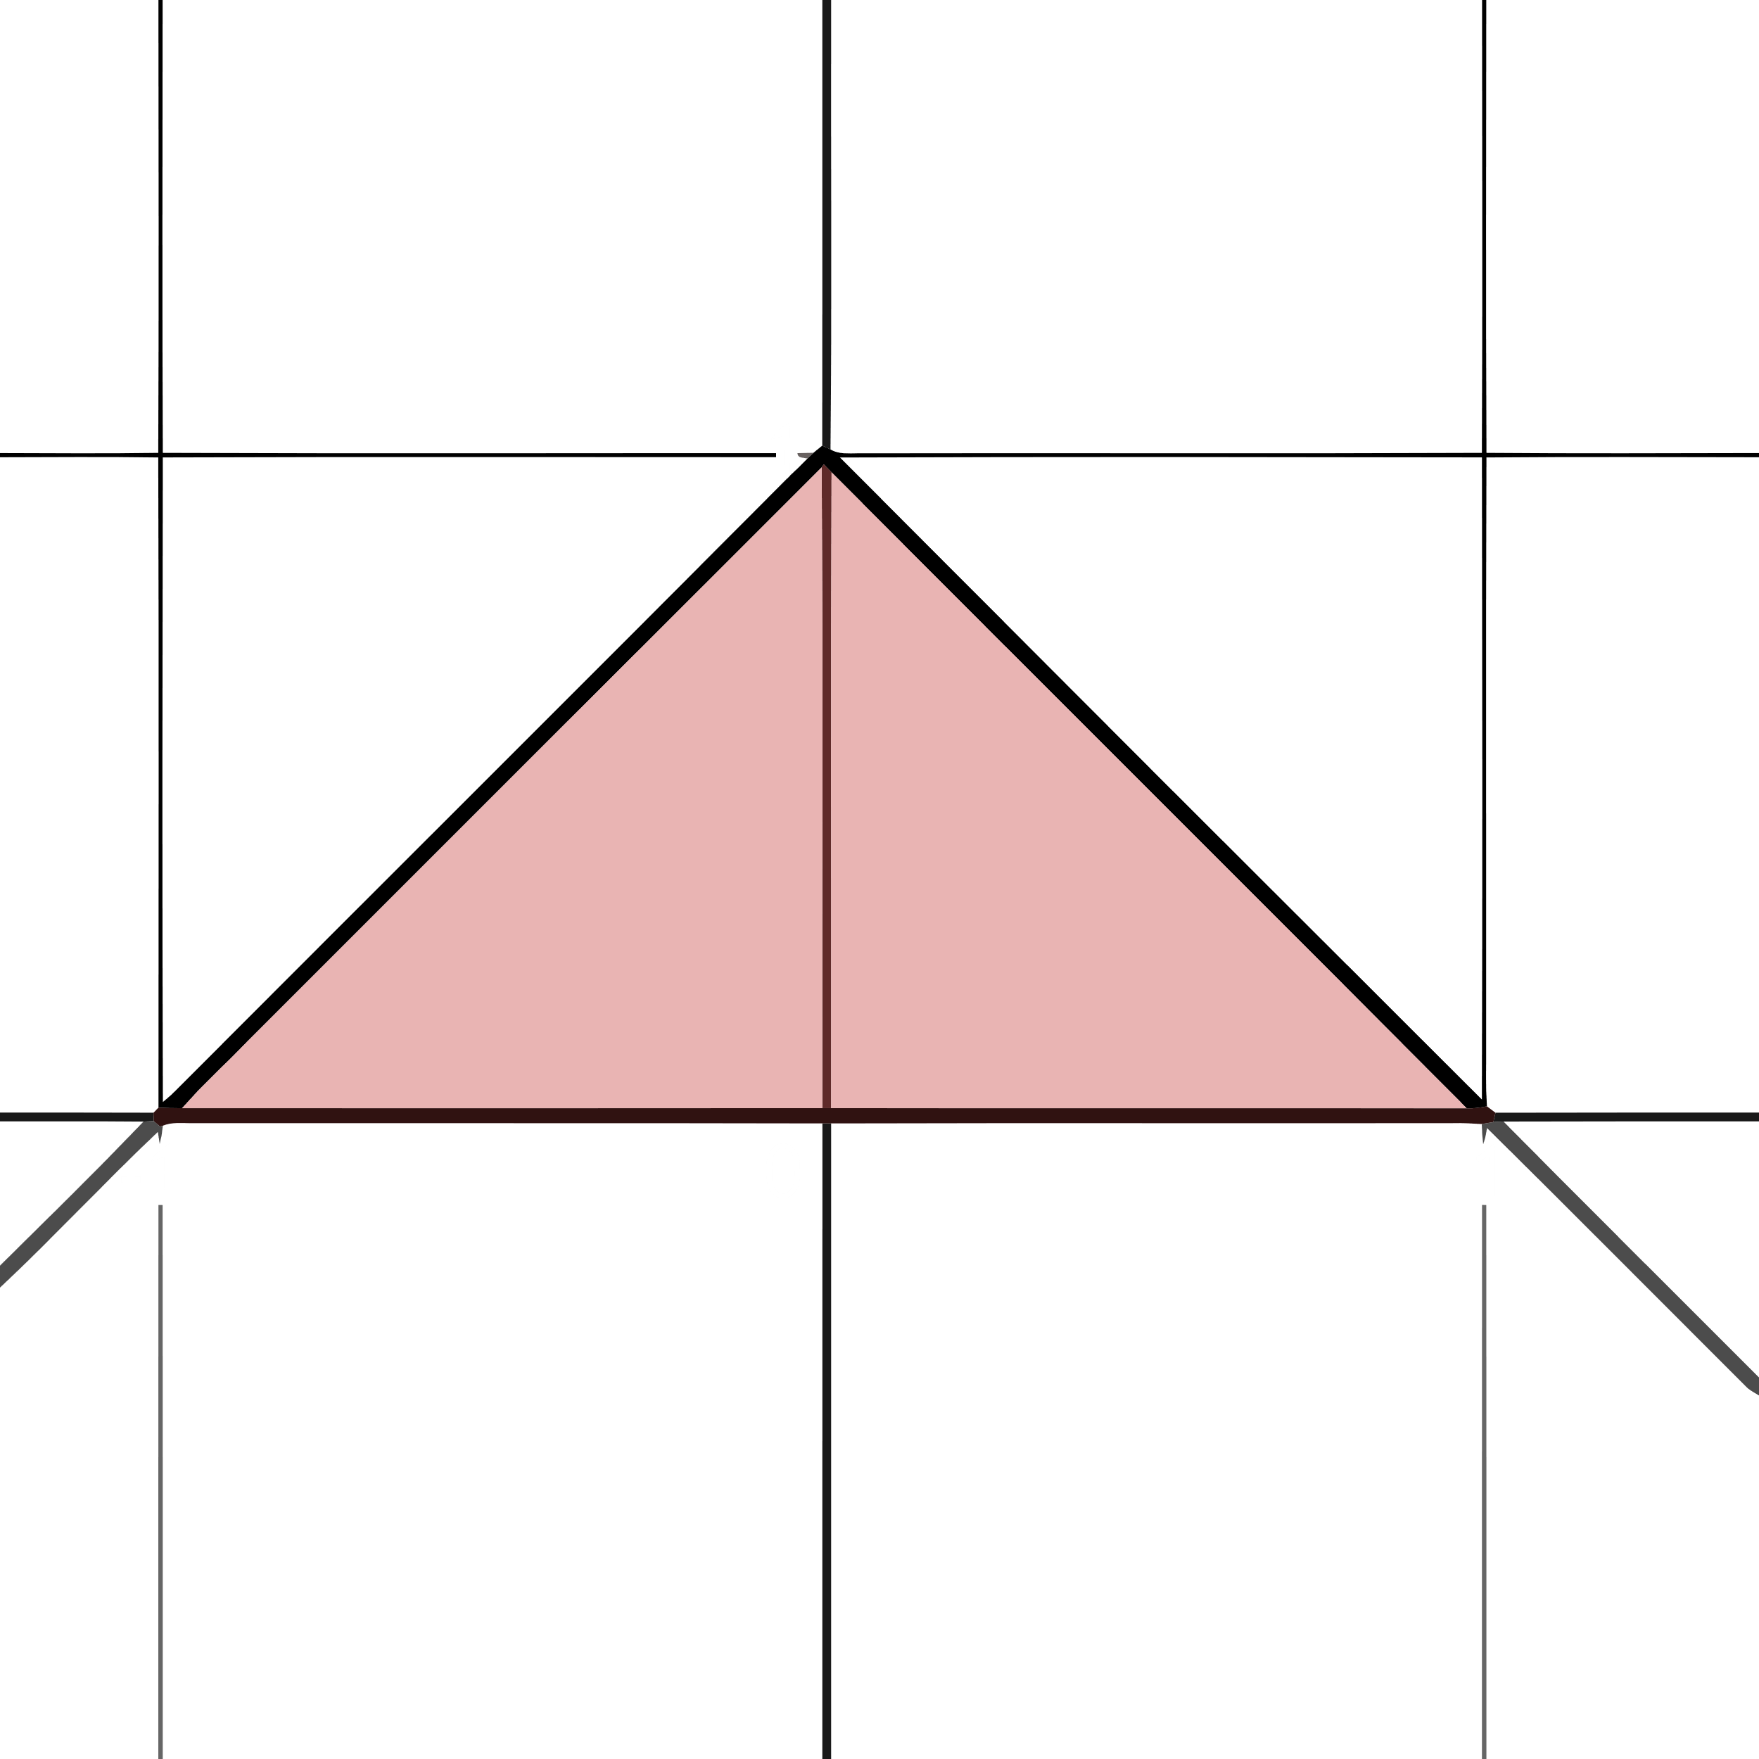

Integrand = $y=1-\left|x\right|=\left\{\begin{matrix}1-x & x>0 \\ 1+x & x≤0\end{matrix}\right.$

$x=1$ $y=0$

$x=-1$ $y=0$

$x=0$ $y=1$

Area = $\frac{1}{2}×1×2=1 units^{2}$

Exercise 55 – 62:

Find the average value.

Exercise 55:

$f\left(x\right)=x^{2}-1$ on $\left[0, \sqrt{3}\right]$

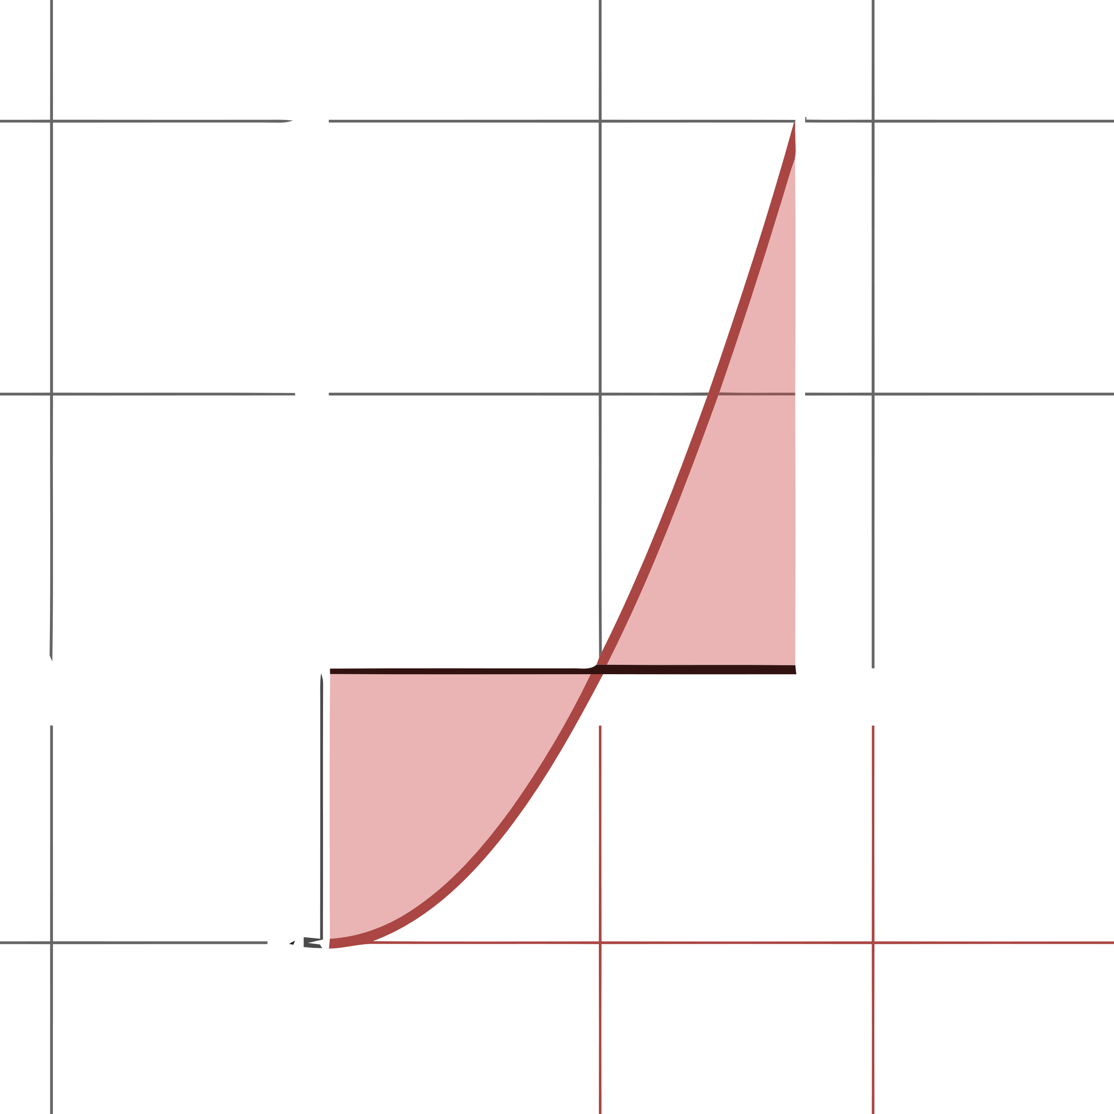

$x=0$ $y=1$

$y=0$ $x=±1$

$$f_{av}=\frac{1}{\sqrt{3}-0}\int_{0}^{\sqrt{3}}{\left(x^{2}-1\right)dx}=\frac{1}{\sqrt{3}}{\left[\frac{x^{3}}{2}-x\right]}_{0}^{\sqrt{3}}=\frac{1}{\sqrt{3}}\left(\frac{{\sqrt{3}}^{3}}{3}-\sqrt{3}\right)=1-1=0 units^{2}$$

Exercise 61:

$g\left(x\right)=\left|x\right|-1$ on

a) $\left[-1, 1\right]$

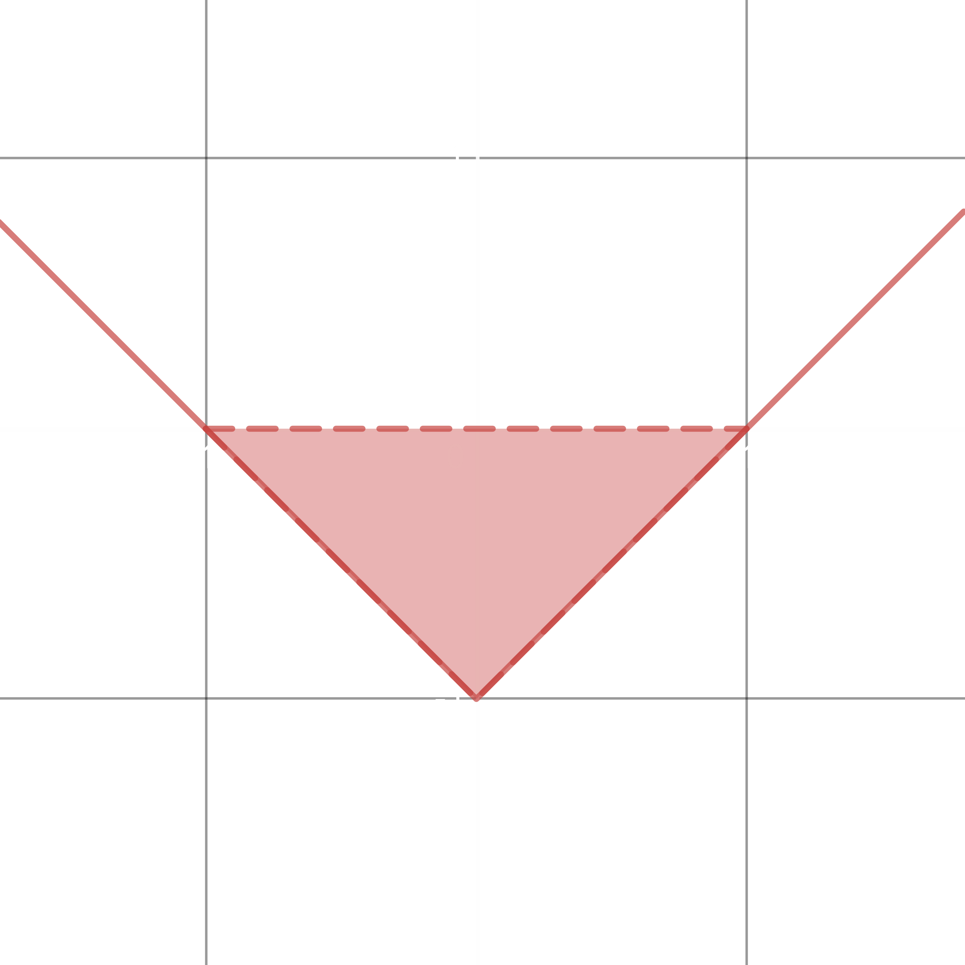

$$\int_{-1}^{1}{\left(\left|x\right|-1\right)dx}=\frac{1}{2}×2×1=1 units^{2}$$

$$f_{av}=\frac{1}{1+1}\int_{-1}^{1}{\left(\left|x\right|-1\right)dx}=\frac{1}{2}×1=\frac{1}{2}$$

b) $\left[1, 3\right]$

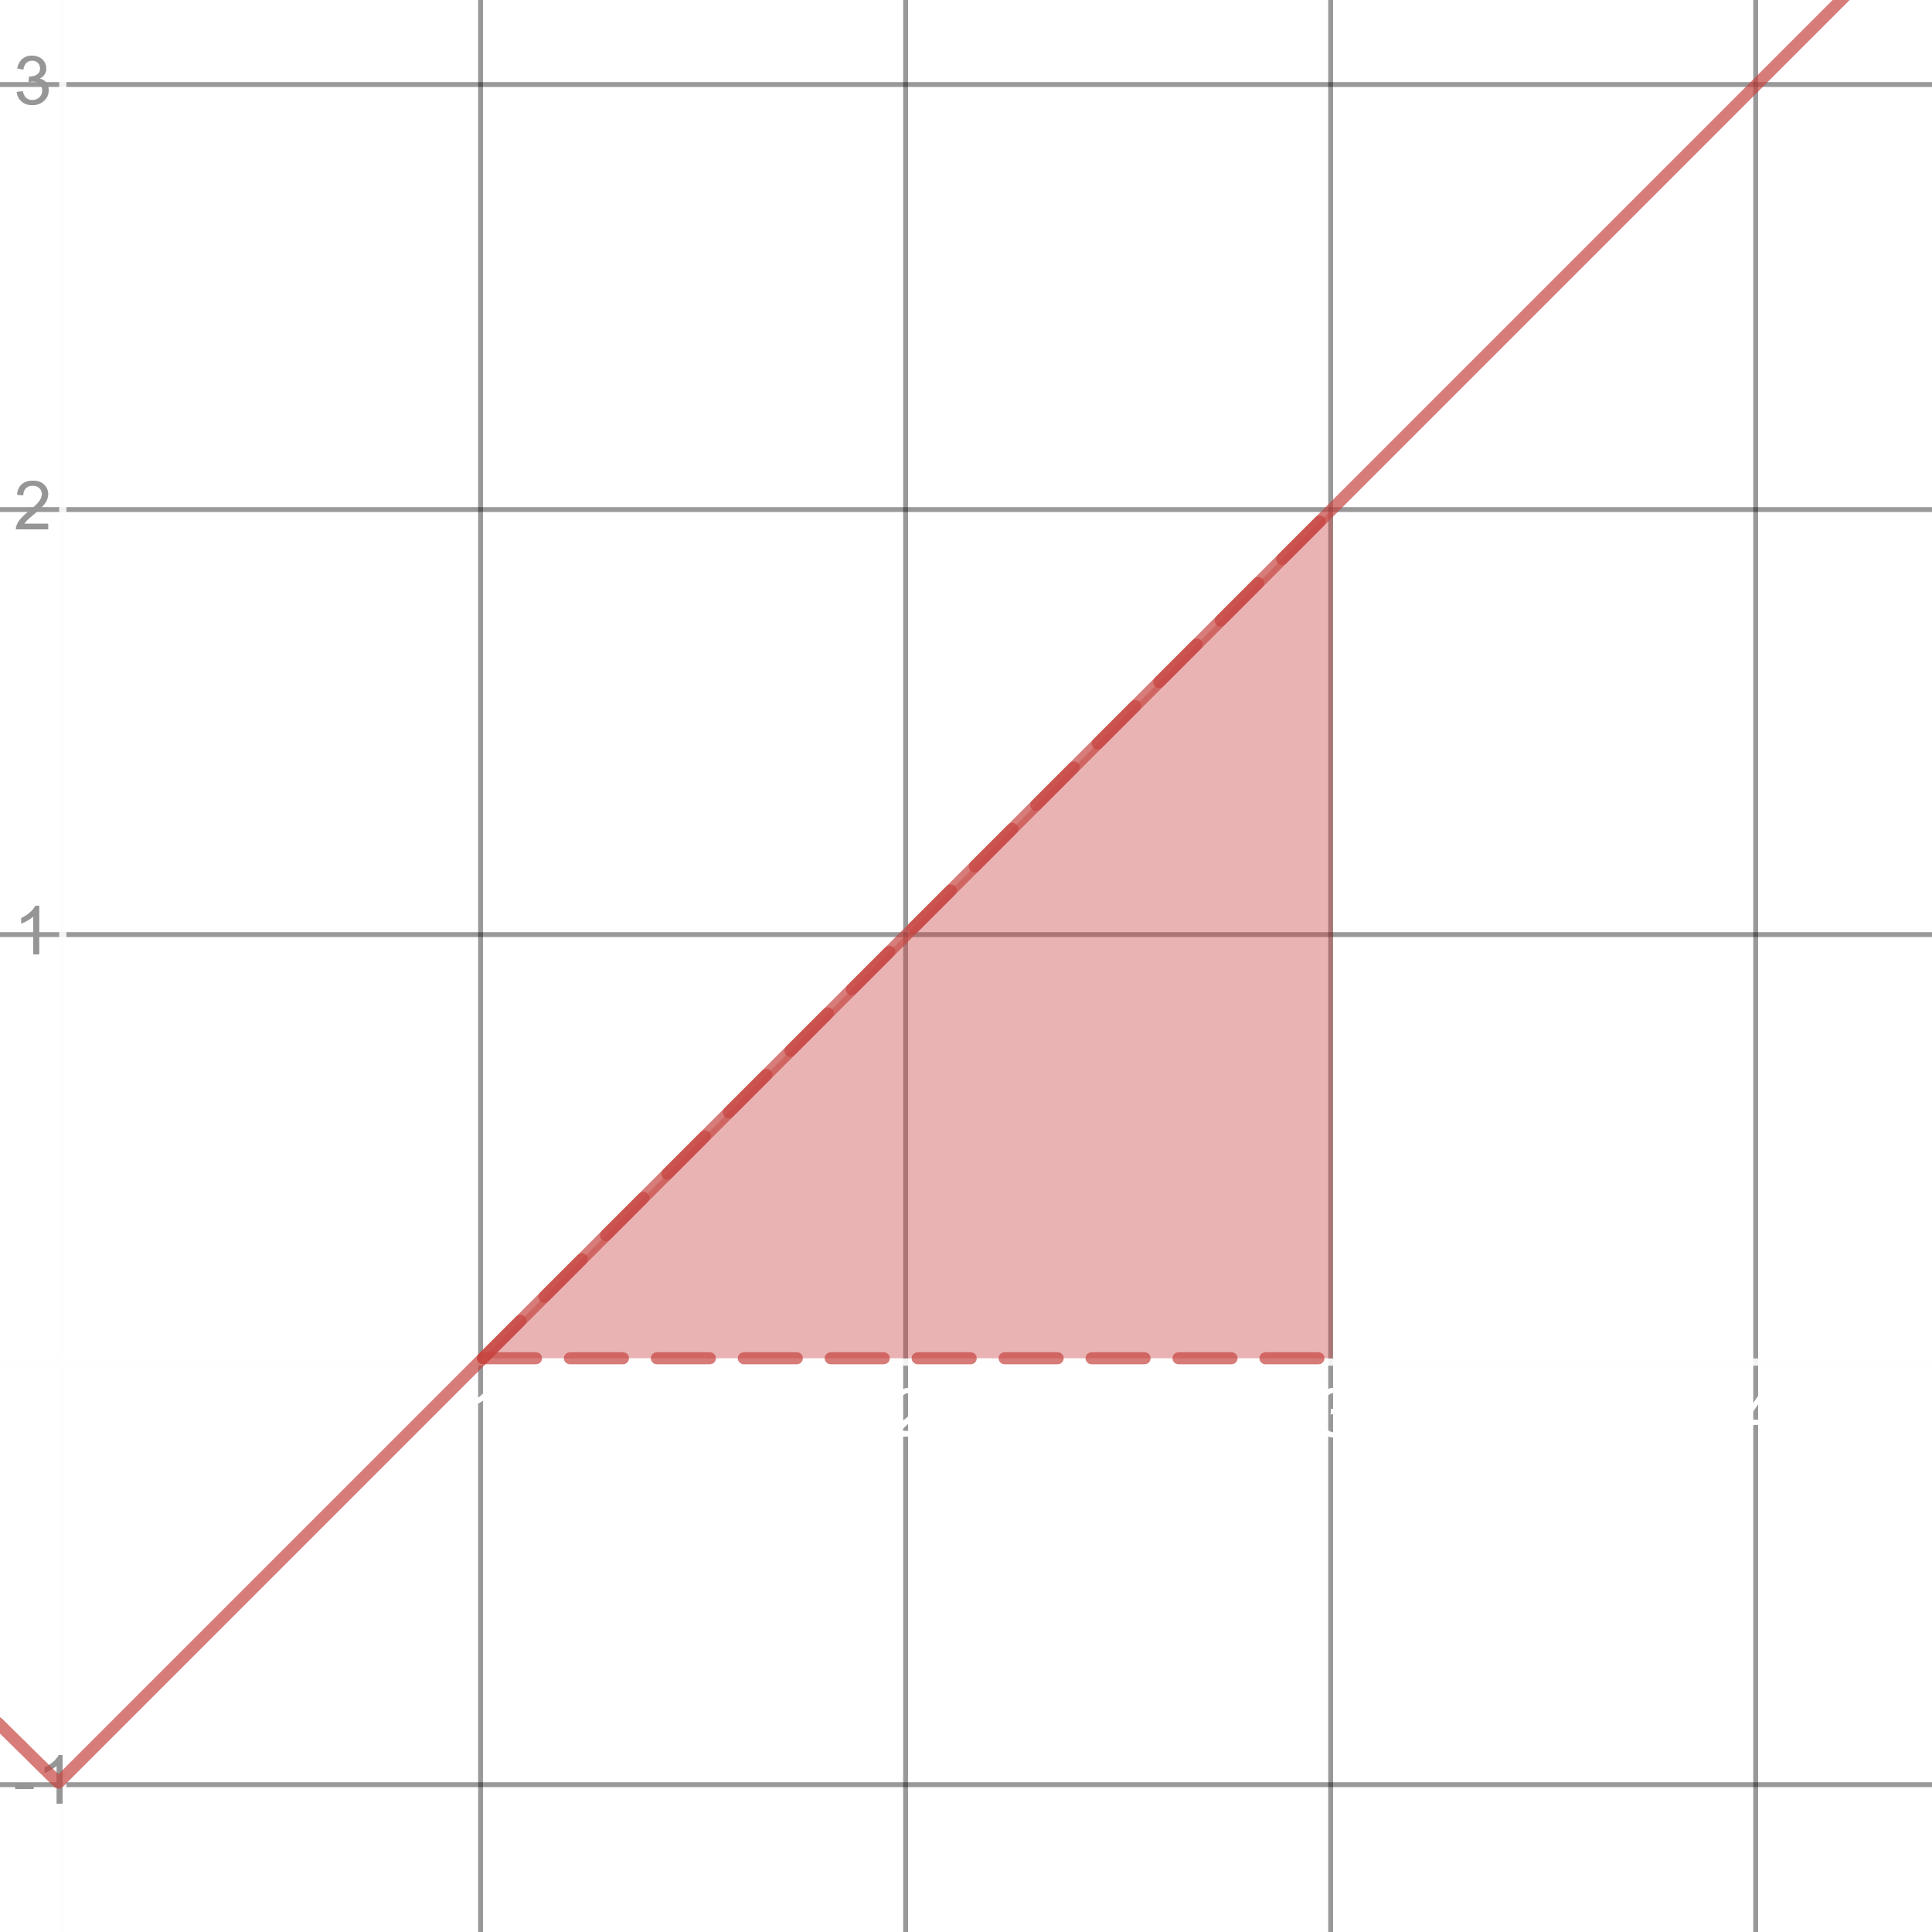

$$\int_{1}^{3}{\left(\left|x\right|-1\right)dx}=\frac{1}{2}×2×2=2 units^{2}$$

$$f_{av}=\frac{1}{3-1}\int_{1}^{3}{\left(\left|x\right|-1\right)dx}=\frac{1}{2}×2=1$$

c) $\left[-1, 3\right]$

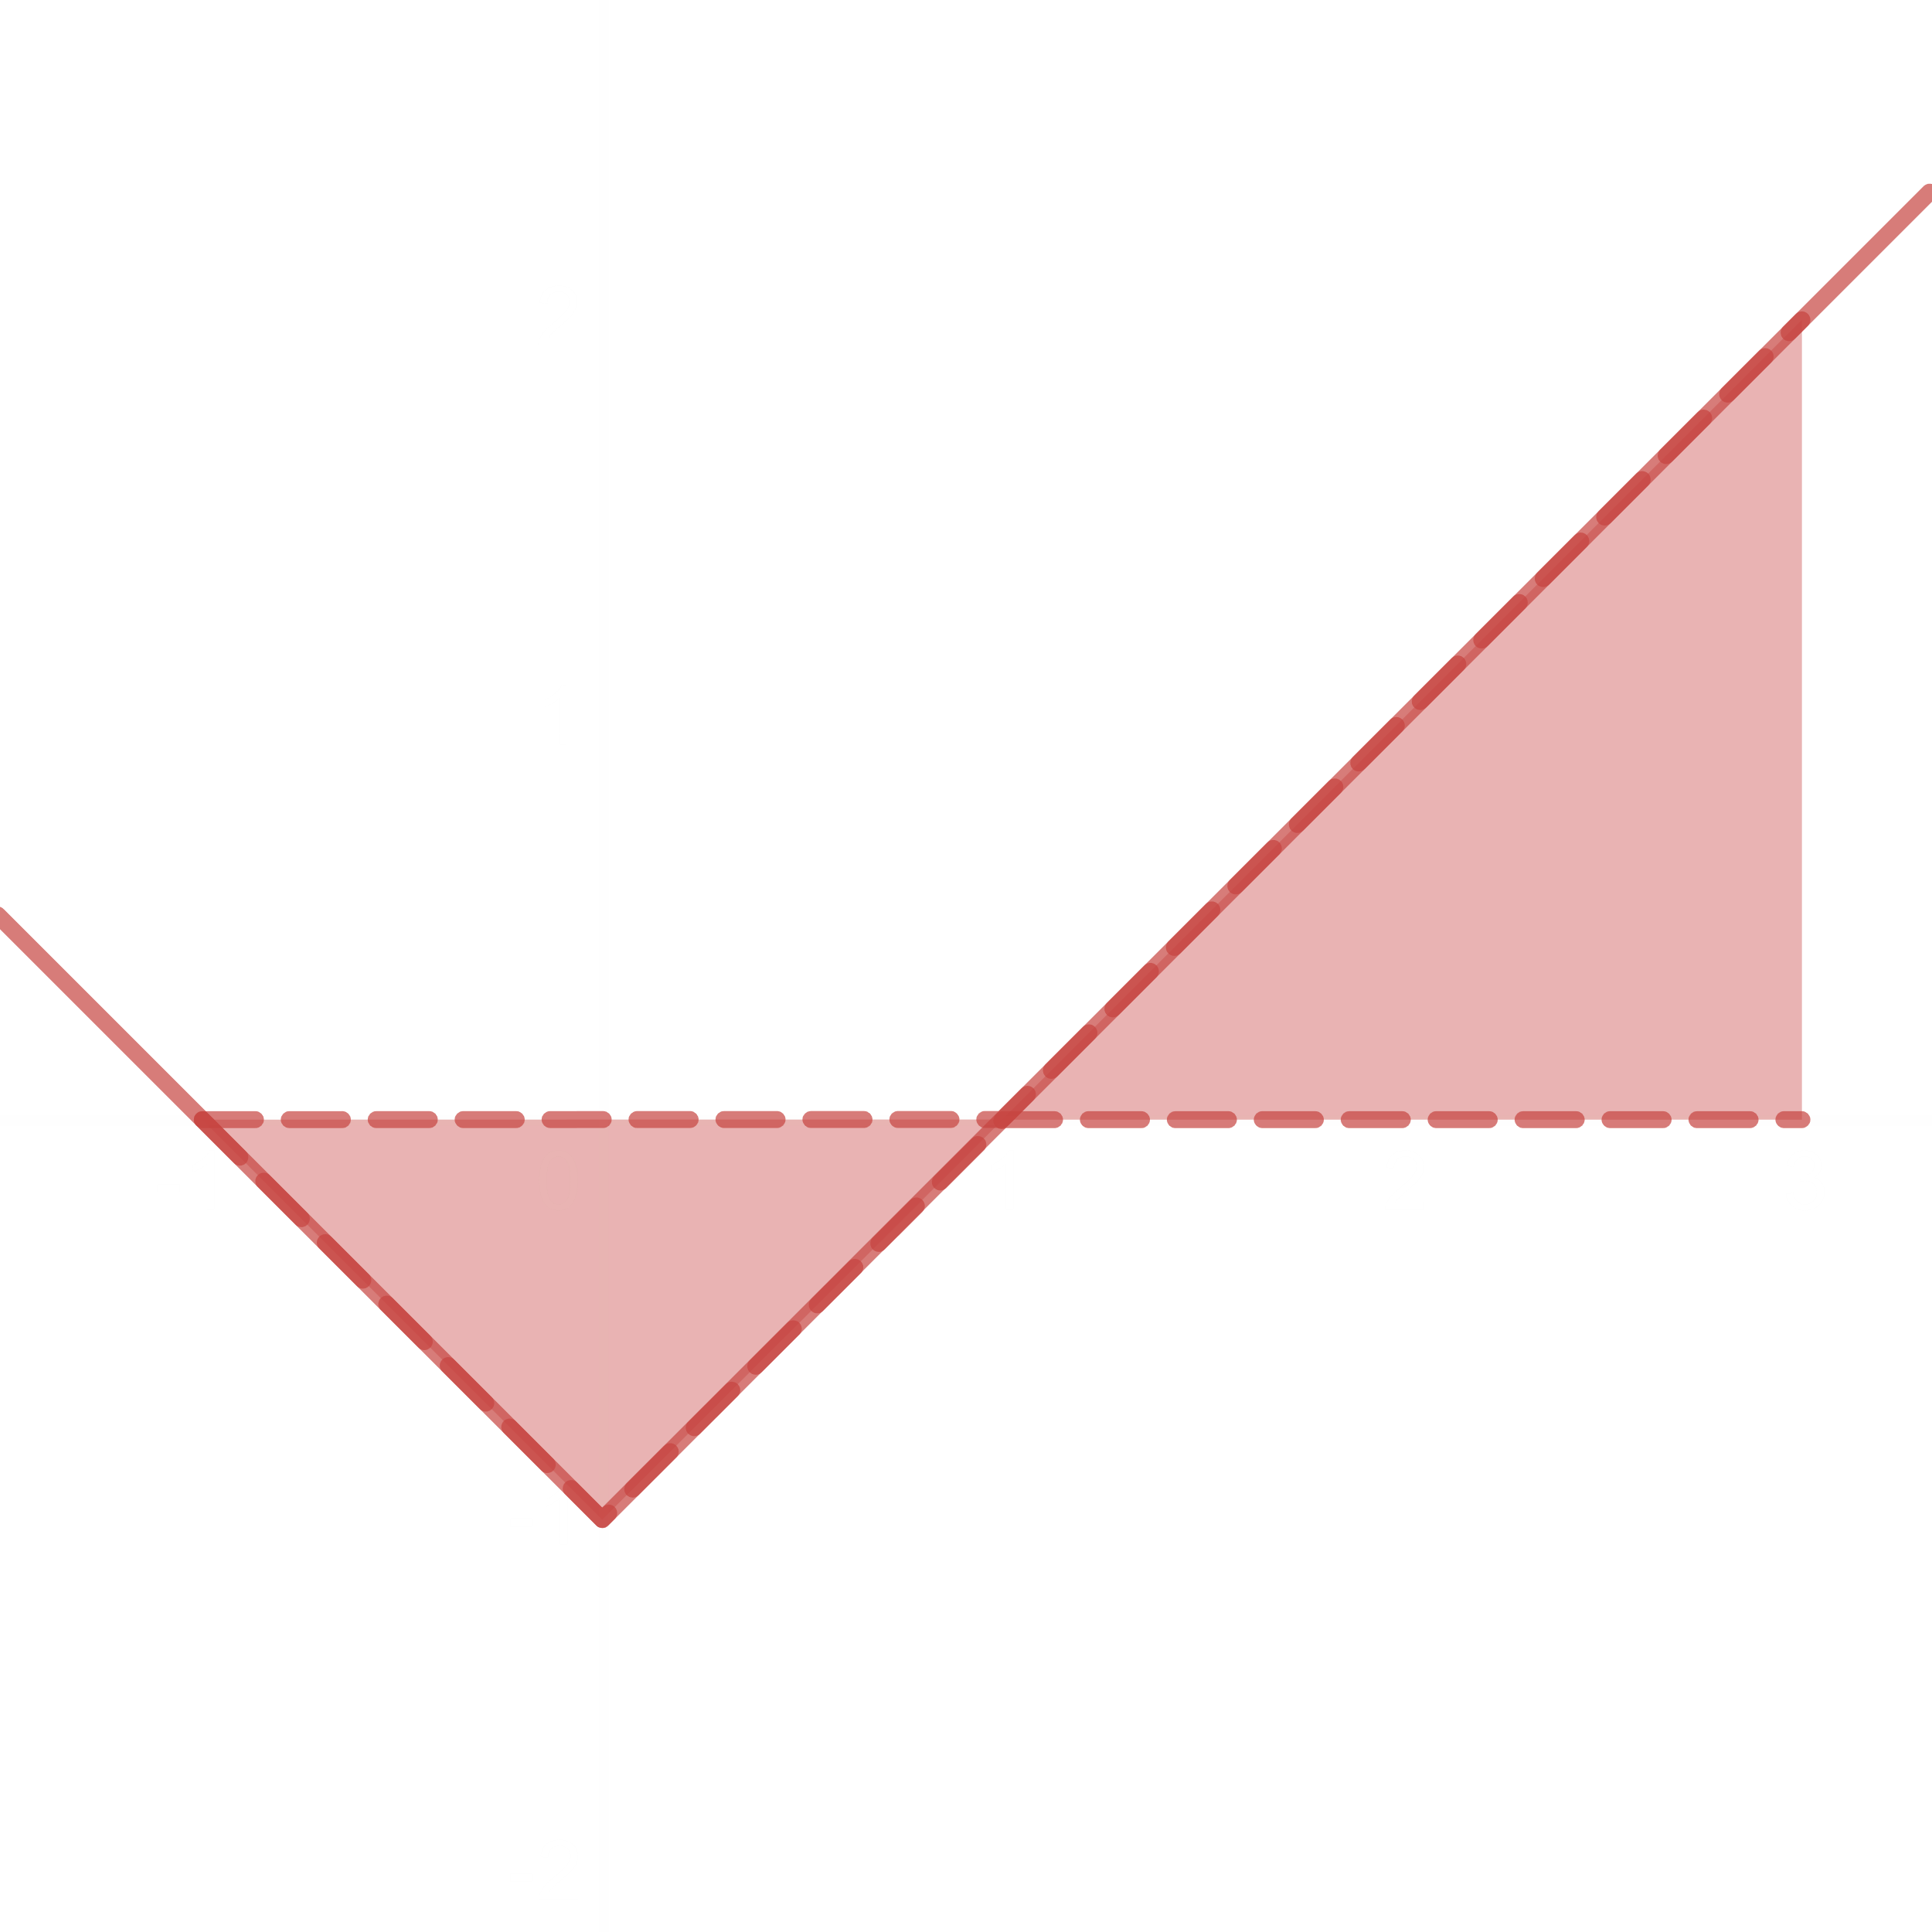

$$\int_{-1}^{3}{\left(\left|x\right|-1\right)dx}=\int_{-1}^{1}{\left(\left|x\right|-1\right)dx}+\int_{1}^{3}{\left(\left|x\right|-1\right)dx}=1+2=3$$

$$f_{av}=\frac{1}{3+1}\int_{-1}^{3}{\left(\left|x\right|-1\right)dx}=\frac{1}{4}×3=\frac{1}{2}\left(\frac{1}{2}+1\right)=\frac{3}{4}$$

## 5.4 The Fundamental Theorem of Calculus

### Theorem 3: The Mean Value Theorem

If $f$ if continuous on $\left[a, b\right]$, then at some point $c$ in $\left[a, b\right]$, $f\left(c\right)=\frac{1}{b-a}\int_{a}^{b}{f\left(x\right)dx}$.

### Theorem 4: The Fundamental Theorem of Calculus (Part 1)

If $f$ is continuous on $\left[a, b\right]$, then $F\left(x\right)=\int_{a}^{x}{f\left(t\right)dt}$ is continuous on $\left[a, b\right]$ and differentiable on $\left(a, b\right)$ and its derivative is $f\left(x\right)$.

$$F^{'}\left(x\right)=\frac{d}{dx}\int_{a}^{x}{f\left(t\right)dt}=f\left(x\right)$$

N.B.: $f\left(t\right)$ and $f\left(x\right)$ are the exact same functions with different variables. The upper limit MUST be $x$.

### Theorem 5: The Fundamental Theorem of Calculus (Part 2)

$$\int_{a}^{b}{f\left(x\right)dx}={\left[F\left(x\right)\right]}_{a}^{b}=F\left(b\right)-F\left(a\right)$$

Example 2

Use the fundamental theorem (part 1) to find $\frac{dy}{dx}$.

a) $y=\int_{a}^{x}{\left(t^{3}+1\right)dt}$

$$F^{'}\left(x\right)=\frac{dy}{dx}=\frac{d}{dx}\int_{a}^{x}{\left(t^{3}+1\right)dt}=x^{3}+1$$

Verification:

$$y=\int_{a}^{x}{\left(t^{3}+1\right)dt}={\left[\frac{t^{4}}{4}+1\right]}_{a}^{x}=\frac{x^{4}}{4}+x+\frac{a^{4}}{4}+a$$

$$\frac{dy}{dx}=x^{3}+1$$

c) $y=\int_{1}^{x^{2}}{\cos{t}dt}$

$$\frac{dy}{dx}=\frac{d}{dx}\int_{1}^{x^{2}}{\cos{t}dt}$$

Since the upper limit has to be $x$,

$$\frac{dy}{dx}=\cos{x^{2}}⋅\frac{d}{dx}\left(x^{2}\right)=2x\cos{x^{2}}$$

d) $y=\int_{1+3x^{2}}^{4}{\frac{1}{2+e^{t}}dt}=-\int_{4}^{1+3x^{2}}{\frac{1}{2+e^{t}}dt}$

$$\frac{dy}{dx}=\frac{d}{dx}\left(-\int_{4}^{1+3x^{2}}{\frac{1}{2+e^{t}}dt}\right)=-\frac{1}{2+e^{1+3x^{2}}}⋅\frac{d}{dx}\left(1+3x^{2}\right)=-\frac{6x}{2+e^{1+3x^{2}}}$$



$$A=\int_{a}^{b}{f\left(x\right)dx}=\left|A_{1}\right|-\left|A_{2}\right|+\left|A_{3}\right|$$

This is known as the Net Signal Area.

Total Area = $\left|A_{1}\right|+\left|A_{2}\right|+\left|A_{3}\right|$

Example 7:

For the graph of $f\left(x\right)=\sin{x}$ between $x=0$ and $x=2π$, find

a) the definite integral of $f\left(x\right)$ over $\left[0, 2π\right]$

b) the area between the graph of $f\left(x\right)$ and the $x$-axis over $\left[0, 2π\right]$



a) $A=\int_{0}^{2π}{\sin{x}dx}={\left[-\cos{x}\right]}_{0}^{2π}=-\cos{2π}+\cos{0}=-1+1=0$

b) $A_{1}=\int_{0}^{π}{\sin{x}dx}={[-\cos{x}]}_{0}^{π}=1+1=2$

$$A_{2}=\int_{π}^{2π}{\sin{x}dx}={\left[-\cos{x}\right]}_{π}^{2π}=-1-1=-2$$

Total Area = $\left|A_{1}\right|+\left|A_{2}\right|=\left|2\right|+\left|-2\right|=4 units^{2}$

Exercise 5.4

1 – 34: Evaluate

27. $\int_{-4}^{4}{\left|x\right|dx}$

Let $y=\left|x\right|=\left\{\begin{matrix}x & x≥0 \\ -x & x<0\end{matrix}\right.$

$$∴\int_{-4}^{4}{\left|x\right|dx}=\int_{0}^{4}{xdx}+\int_{-4}^{0}{-xdx}={\left[\frac{x^{2}}{2}\right]}_{0}^{4}+{\left[-\frac{x^{2}}{2}\right]}_{-4}^{0}=\frac{4^{2}}{2}-0-0+\frac{{\left(-4\right)}^{2}}{2}=16$$

28. $\int_{0}^{π}{\frac{1}{2}\left(\cos{x}+\left|\cos{x}\right|\right)dx}$

Let $y=\left|\cos{x}\right|=\left\{\begin{matrix}\cos{x} & 0≤x≤\frac{π}{2} \\ -\cos{x} & \frac{π}{2}<x≤π\end{matrix}\right.$

$$∴\int_{0}^{π}{\frac{1}{2}\left(\cos{x}+\left|\cos{x}\right|\right)dx}=\frac{1}{2}\left(\int_{0}^{π}{\cos{x}dx}+\int_{0}^{\frac{π}{2}}{\cos{x}dx}+\int_{\frac{π}{2}}^{π}{-\cos{x}dx}\right)$$

$$=\frac{1}{2}\left({\left[\sin{x}\right]}_{0}^{π}+{\left[\sin{x}\right]}_{0}^{\frac{π}{2}}-{\left[\sin{x}\right]}_{\frac{π}{2}}^{π}\right)=\frac{1}{2}\left(0-0+1-0-0+1\right)=1 units^{2}$$

$$\int{a^{x}dx}=\frac{a^{x}}{\ln{a}}$$

34. $\int_{-1}^{0}{π^{x-1}dx}={\left[\frac{π^{x-1}}{\ln{π}}\right]}_{-1}^{0}=\frac{1}{π\ln{π}}-\frac{1}{π^{2}\ln{π}}$

Exercise 39 – 44

Find the derivatives by

a) evaluating the integral and then differentiating the results

b) differentiating the integral directly

43. a)

b)

Exercise 45 – 56

Find $\frac{dy}{dx}$.

52. $y=\int_{\tan{x}}^{0}{\frac{dt}{1+t^{2}}}=-\int_{0}^{\tan{x}}{\frac{dt}{1+t^{2}}}$

$$\frac{dy}{dx}=-\frac{d}{dx}\int_{0}^{\tan{x}}{\frac{dt}{1+t^{2}}}=-\frac{1}{1+\tan^{2}{x}}⋅\frac{d}{dx}\left(\tan{x}\right)=-\frac{\sec^{2}{x}}{\sec^{2}{x}}=-1$$

Exercise 57 – 60

Find the total area between the region and $x$-axis.

The total area $A=\int_{a}^{b}{\left|f\left(x\right)\right|dx}$

57. $y=-x^{2}-2x$ $3≤x≤2$

$y=0$ $x=-2, 0, 2$

Total area $A=\int_{a}^{b}{\left|f\left(x\right)\right|dx}$

$$A=\int_{-3}^{2}{\left|-x^{2}-2x\right|dx}=\left|\int_{-3}^{-2}{\left(-x^{2}-2x\right)dx}\right|+\left|\int_{-2}^{0}{\left(-x^{2}-2x\right)dx}\right|+\left|\int_{0}^{2}{\left(-x^{2}-2x\right)dx}\right|$$

$$A=\left|{\left[-\frac{x^{3}}{3}-x^{2}\right]}_{-3}^{-2}\right|+\left|{\left[-\frac{x^{3}}{3}-x^{2}\right]}_{-2}^{0}\right|+\left|{\left[-\frac{x^{3}}{3}-x^{2}\right]}_{0}^{2}\right|=\left|-\frac{4}{3}-0\right|+\left|0+\frac{4}{3}\right|+\left|-\frac{20}{3}\right|$$

$$A=\frac{28}{3}units^{2}$$

59. $y=x^{3}-3x^{2}+2x$ $0≤x≤2$

$y=0$ $x=0, 1, 2$

$$A=\int_{a}^{b}{\left|f\left(x\right)\right|dx}=\int_{0}^{2}{\left(x^{3}-3x^{2}+2x\right)dx}$$

$$A=\left|\int_{0}^{1}{\left(x^{3}-3x^{2}+2x\right)dx}\right|+\left|\int_{1}^{2}{\left(x^{3}-3x^{2}+2x\right)dx}\right|$$

$$A=\left|{\left[\frac{x^{4}}{4}-x^{3}+x^{2}\right]}_{0}^{1}\right|+\left|{\left[\frac{x^{4}}{4}-x^{3}+x^{2}\right]}_{1}^{2}\right|=\left|\frac{1}{4}-1+1\right|+\left|4-8+4-\frac{1}{4}+1-1\right|$$

$$A=0.5 units^{2}$$

## 5.5 Substitution Method

Example 5:

$$\int{x^{2}e^{x^{3}}dx}$$

Let $x^{3}=z$.

$$∴3x^{2}dx=dz$$

$$∴x^{2}dx=\frac{1}{3}dz$$

$$∴\int{x^{2}e^{x^{3}}dx}$$

$$=\int{\frac{1}{3}e^{z}dz}$$

$$=\frac{1}{3}e^{z}+c$$

$$=\frac{1}{3}e^{x^{3}}+c$$

Example 7:

$$\int{x\sqrt{2x+1}dx}$$

Let $2x+1=z^{2}$.

$$∴2dx=2zdz$$

$$∴dx=zdz$$

Also, since $2x+1=z^{2}$

$$x=\frac{z^{2}-1}{2}$$

$$∴\int{x\sqrt{2x+1}dx}$$

$$=\int{\left(\frac{z^{2}-1}{2}\right)×z×zdz}$$

$$=\int{\left(\frac{z^{4}}{2}-\frac{z^{2}}{2}\right)dz}$$

$$=\frac{z^{5}}{10}-\frac{z^{3}}{6}+c$$

$$=\frac{{\left(2x+1\right)}^{\frac{5}{2}}}{10}-\frac{{\left(2x+1\right)}^{\frac{3}{2}}}{6}+c$$

$$I=\int{\sin^{2}{x}dx}$$

We know, $\cos{2x}=\cos^{2}{x}-\sin^{2}{x}=1-2\sin^{2}{x}$.

$$∴\sin^{2}{x}=\frac{1-\cos{2x}}{2}$$

$$∴I=\int{\sin^{2}{x}dx}=\int{\left(\frac{1-\cos{2x}}{2} \right)dx}$$

$$I=\frac{x}{2}-\frac{\sin{2x}}{4}+c$$

$$I=\int{\sin^{3}{x}dx}$$

$$I=\int{\sin^{2}{x}⋅\sin{x}dx}$$

$$I=\int{\left(1-\cos^{2}{x}\right)⋅\sin{x}dx}$$

Let $\cos{x}=z$.

$$∴-\sin{x}dx=dz$$

$$∴I=\int{\left(1-\cos^{2}{x}\right)⋅\sin{x}dx}=\int{\left(1-z^{2}\right)\left(-dz\right)}$$

$$I=\int{\left(z^{2}-1\right)dz}$$

$$I=\frac{z^{3}}{3}-z+c$$

$$∴I=\frac{\cos^{3}{x}}{3}-\cos{x}+c$$

$$I=\int{\sin^{4}{x}dx}=\int{{\left(\sin^{2}{x}\right)}^{2}dx}$$

We know, $\sin^{2}{x}=\frac{1-\cos{2x}}{2}$.

$$∴I=\int{{\left(\sin^{2}{x}\right)}^{2}dx}=\int{{\left(\frac{1-\cos{2x}}{2}\right)}^{2}dx}$$

$$I=\frac{1}{4}\int{\left(1-2\cos{2x}+\cos^{2}{2x}\right)dx}$$

$$I=\frac{1}{4}x-\frac{\sin{2x}}{4}+\frac{1}{4}\int{\cos^{2}{2x}dx}$$

We know, $\cos^{2}{x}=\frac{1+\cos{2x}}{2}$.

$$∴I=\frac{1}{4}x-\frac{\sin{2x}}{4}+\frac{1}{4}\int{\left(\frac{1+\cos{4x}}{2}\right)dx}$$

$$I=\frac{1}{4}x-\frac{\sin{2x}}{4}+\frac{1}{8}\left(x+\frac{\sin{4x}}{4}\right)+c$$

$$∴I=\frac{3x}{8}-\frac{\sin{2x}}{4}+\frac{\sin{4x}}{32}+c$$

Exercise 1 – 65:

Exercise 21:

$$\int{\frac{dx}{\sqrt{x}{\left(1+\sqrt{x}\right)}^{2}}}$$

Let $x=z^{2}$.

$$∴dx=2zdz$$

$$∴\int{\frac{dx}{\sqrt{x}{\left(1+\sqrt{x}\right)}^{2}}}$$

$$=\int{\frac{2z}{z{\left(1+z\right)}^{2}}dz}$$

$$=\int{2{\left(1+z\right)}^{-2}dz}$$

$$=-2{\left(1+z\right)}^{-1}+c$$

$$=-\frac{2}{1+\sqrt{x}}+c$$

Exercise 52:

$$\int{\left(\sin{2θ}⋅e^{\sin^{2}{θ}}\right)dθ}$$

Let $\sin^{2}{θ}=z$.

$$∴2\sin{θ}\cos{θ}dθ=dz$$

$$∴\sin{2θ}dθ=dz$$

$$∴\int{\left(\sin{2θ}⋅e^{\sin^{2}{θ}}dθ\right)}$$

$$=\int{e^{z}dz}$$

$$=e^{z}+c$$

$$=e^{\sin^{2}{θ}}+c$$

Exercise 57:

$$\int{\frac{dx}{1+e^{x}}}$$

$$=\int{\left(\frac{1}{e^{x}}×\frac{1}{\frac{1}{e^{x}}+1}\right)dx}$$

$$=\int{\frac{e^{-x}}{1+e^{-x}}dx}$$

Let $1+e^{-x}=z$.

$$∴-e^{-x}dx=dz$$

$$∴\int{\left(\frac{e^{-x}}{1+e^{-x}}\right)dx}$$

$$=\int{-\left(\frac{1}{z}\right)dz}$$

$$=-\ln{z}=-\ln\left(1+e^{-x}\right)+c$$

Exercise 55.

$$\int{\frac{dx}{x\ln{x}}}$$

Let $\ln{x}=z$.

$$∴\frac{1}{x}dx=dz$$

$$∴\int{\frac{dx}{x\ln{x}}}$$

$$=\int{\frac{1}{z}dz}$$

$$=\ln{z}$$

$$=\ln\left(\ln{x}\right)$$

Exercise 63:

$$\int{\left(\frac{{\left(\sin^{-1}{x}\right)}^{2}}{\sqrt{1-x^{2}}}\right)dx}$$

Let $\sin^{-1}{x}=z$.

We know, $\frac{d}{dx}\left(\sin^{-1}{x}\right)=\frac{1}{\sqrt{1-x^{2}}}$

$$∴\frac{1}{\sqrt{1-x^{2}}}dx=dz$$

$$∴\int{\frac{{\left(\sin^{-1}{x}\right)}^{2}}{\sqrt{1-x^{2}}}dx}$$

$$=\int{z^{2}dz}$$

$$=\frac{z^{3}}{3}+c$$

$$=\frac{{\left(\sin^{-1}{x}\right)}^{3}}{3}+c$$

Exercise 53:

$$\int{\frac{1}{\sqrt{x}⋅e^{-\sqrt{x}}}⋅\sec^{2}\left(e^{\sqrt{x}}+1\right)dx}$$

Let $e^{\sqrt{x}}+1=z$.

$$∴\frac{e^{\sqrt{x}}}{2\sqrt{x}}dx=dz$$

$$∴\int{\frac{1}{\sqrt{x}⋅e^{-\sqrt{x}}}⋅\sec^{2}\left(e^{\sqrt{x}}+1\right)dx}$$

$$=\int{\frac{e^{\sqrt{x}}}{\sqrt{x}}⋅\sec^{2}\left(e^{\sqrt{x}}+1\right)dx}$$

$$=\int{2\sec^{2}{z}dz}$$

$$=2\tan{z}+c$$

$$=2\tan\left(e^{\sqrt{x}}+1\right)+c$$

It is estimated that $x$ months from now, the population of a certain town will be changing at a rate of $2+6\sqrt{x}$ people per month. The current population is $5000$. What will be the population $9$ months from now?

Let $P$ be the population at a given time $x$.

$$∴\frac{dP}{dx}=2+6\sqrt{x}$$

$$P=\int{\left(2+6\sqrt{x}\right)dx}$$

$$P=2x+4x^{\frac{3}{2}}+c$$

Since the current population is $5000$, at $x=0$,

$$P=20+40+c=5000$$

$$∴c=5000$$

$$∴P=2x+4x32+5000$$

$9$ months from now, at $x=9$, the population will be,

$$P=2\left(9\right)+4{\left(9\right)}^{\frac{3}{2}}+5000=5126$$

## 5.6 Substitution and Area Between Curves

Example 1

$$\int_{-1}^{1}{3x^{2}\sqrt{x^{3}+1}dx}$$

Let $z=x^{3}+1$.

$$dx=3x^{2}dx$$

$x=-1$ $z=0$

$x=1$ $z=2$

$$\int_{-1}^{1}{3x^{2}\sqrt{x^{3}+1}dx}=\int_{0}^{2}{\sqrt{z}dz}={\left[\frac{2z^{\frac{3}{2}}}{3}\right]}_{0}^{2}=1.89 units^{2}$$

Even Function: $f\left(x\right)=f\left(-x\right)$

Odd Function: $f\left(x\right)=-f\left(-x\right)$

Theorem 8: Let $f$ be continuous on the symmetrical interval $\left[-a, a\right]$. Then,

a) $\int_{-a}^{a}{f\left(x\right)dx}=2\int_{0}^{a}{f\left(x\right)dx}$ if $f\left(x\right)$ is even

b) $\int_{-a}^{a}{f\left(x\right)dx}=0$ if $f\left(x\right)$ is odd

Proofs:

a) $I=\int_{-a}^{a}{f\left(x\right)dx}=\int_{-a}^{0}{f\left(x\right)dx}+\int_{0}^{a}{f\left(x\right)dx}=-\int_{0}^{-a}{f\left(x\right)dx}+\int_{0}^{a}{f\left(x\right)dx}$

Let $x=-u$ be in the 1st integral.

- (i)

From the definition of an even function,

$$f\left(u\right)=f\left(-u\right)$$

$$∴I=\int_{0}^{a}{f\left(u\right)du}+\int_{0}^{a}{f\left(x\right)dx}$$

Using the property $\int_{a}^{b}{f\left(x\right)dx}=\int_{a}^{b}{f\left(z\right)dz}$,

$$I=\int_{0}^{a}{f\left(x\right)dx}+\int_{0}^{a}{f\left(x\right)dx}=2\int_{0}^{a}{f\left(x\right)dx}$$

b) From equation (i),

$$I=\int_{-a}^{a}{f\left(x\right)dx}=\int_{0}^{a}{f\left(-u\right)du}+\int_{0}^{a}{f\left(x\right)dx}$$

From the definition of an odd function,

$$f\left(-u\right)=-f\left(u\right)$$

$$∴I=-\int_{0}^{a}{f\left(u\right)du}+\int_{0}^{a}{f\left(x\right)dx}$$

Using the property $\int_{a}^{b}{f\left(x\right)dx}=\int_{a}^{b}{f\left(z\right)dz}$

$$I=-\int_{0}^{a}{f\left(x\right)dx}+\int_{0}^{a}{f\left(x\right)dx}=0$$

Area Between Curves

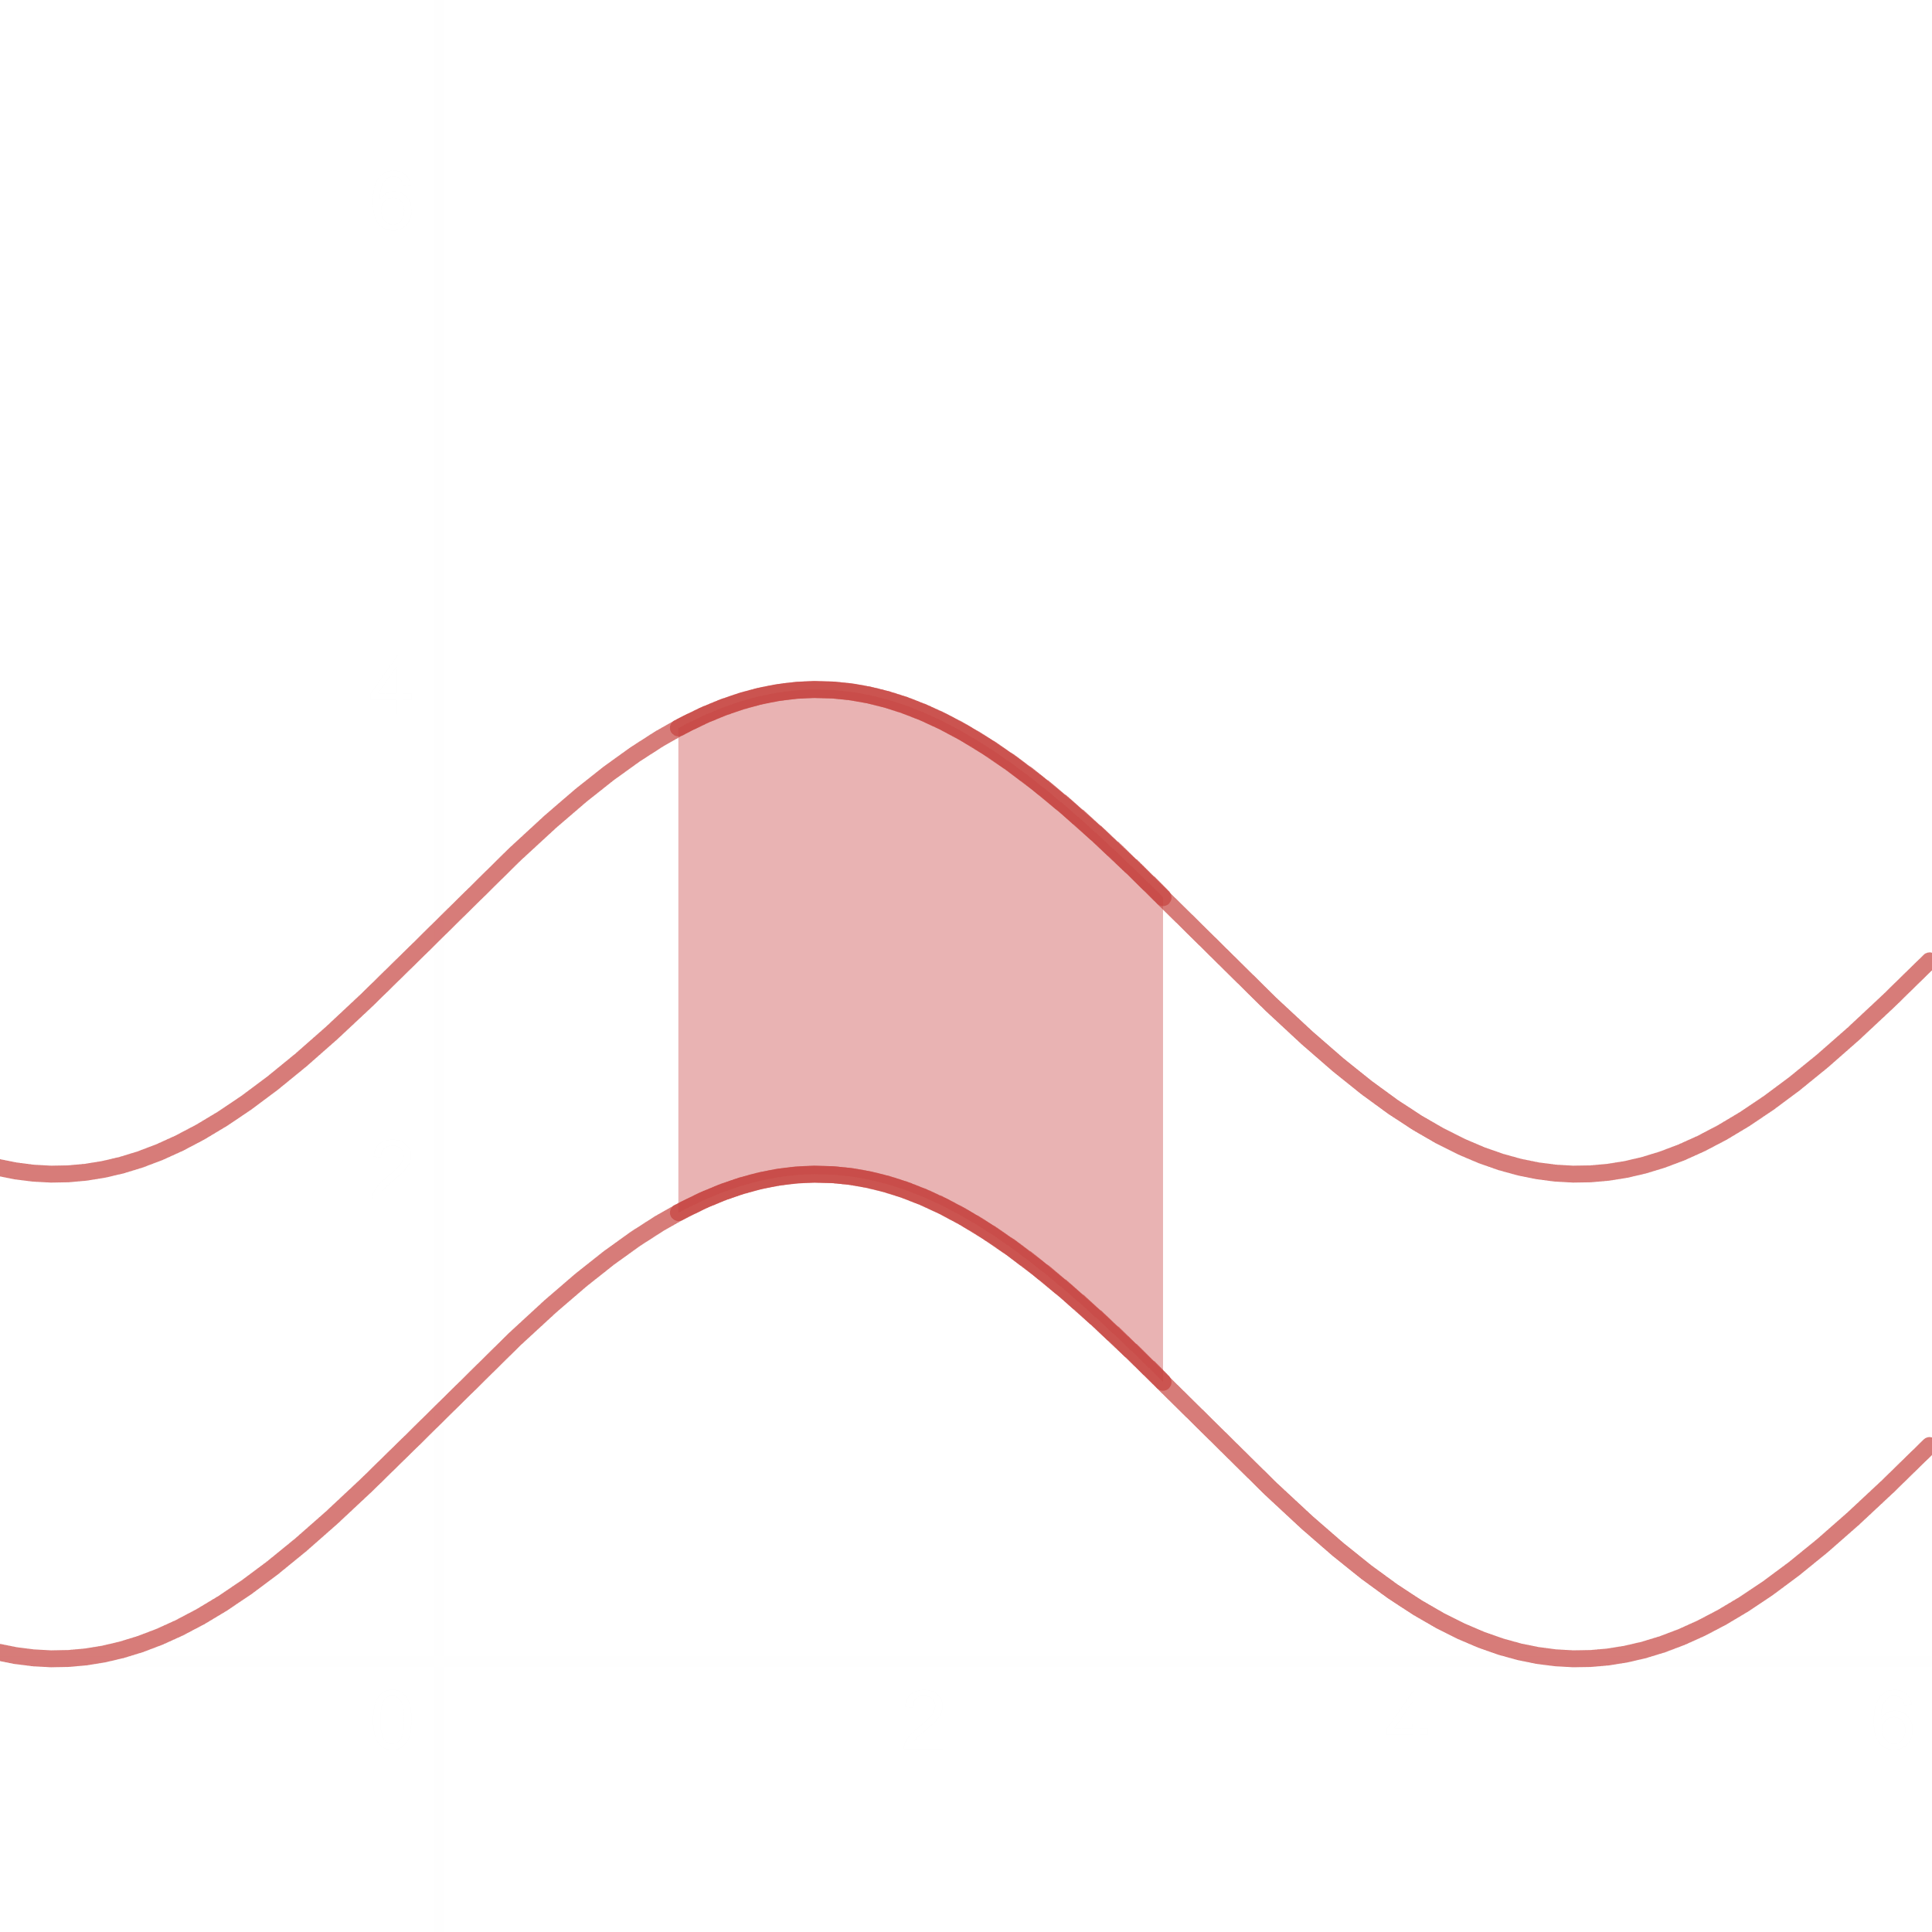

If $f$ and $g$ are continuous with $f\left(x\right)≥g\left(x\right)$ throughout the interval $\left[a, b\right]$, then the area of the region between the curves $y=f\left(x\right)$ and $y=g\left(x\right)$ from $a$ to $b$ is $\int_{a}^{b}{\left[f\left(x\right)-g\left(x\right)\right]dx}$.

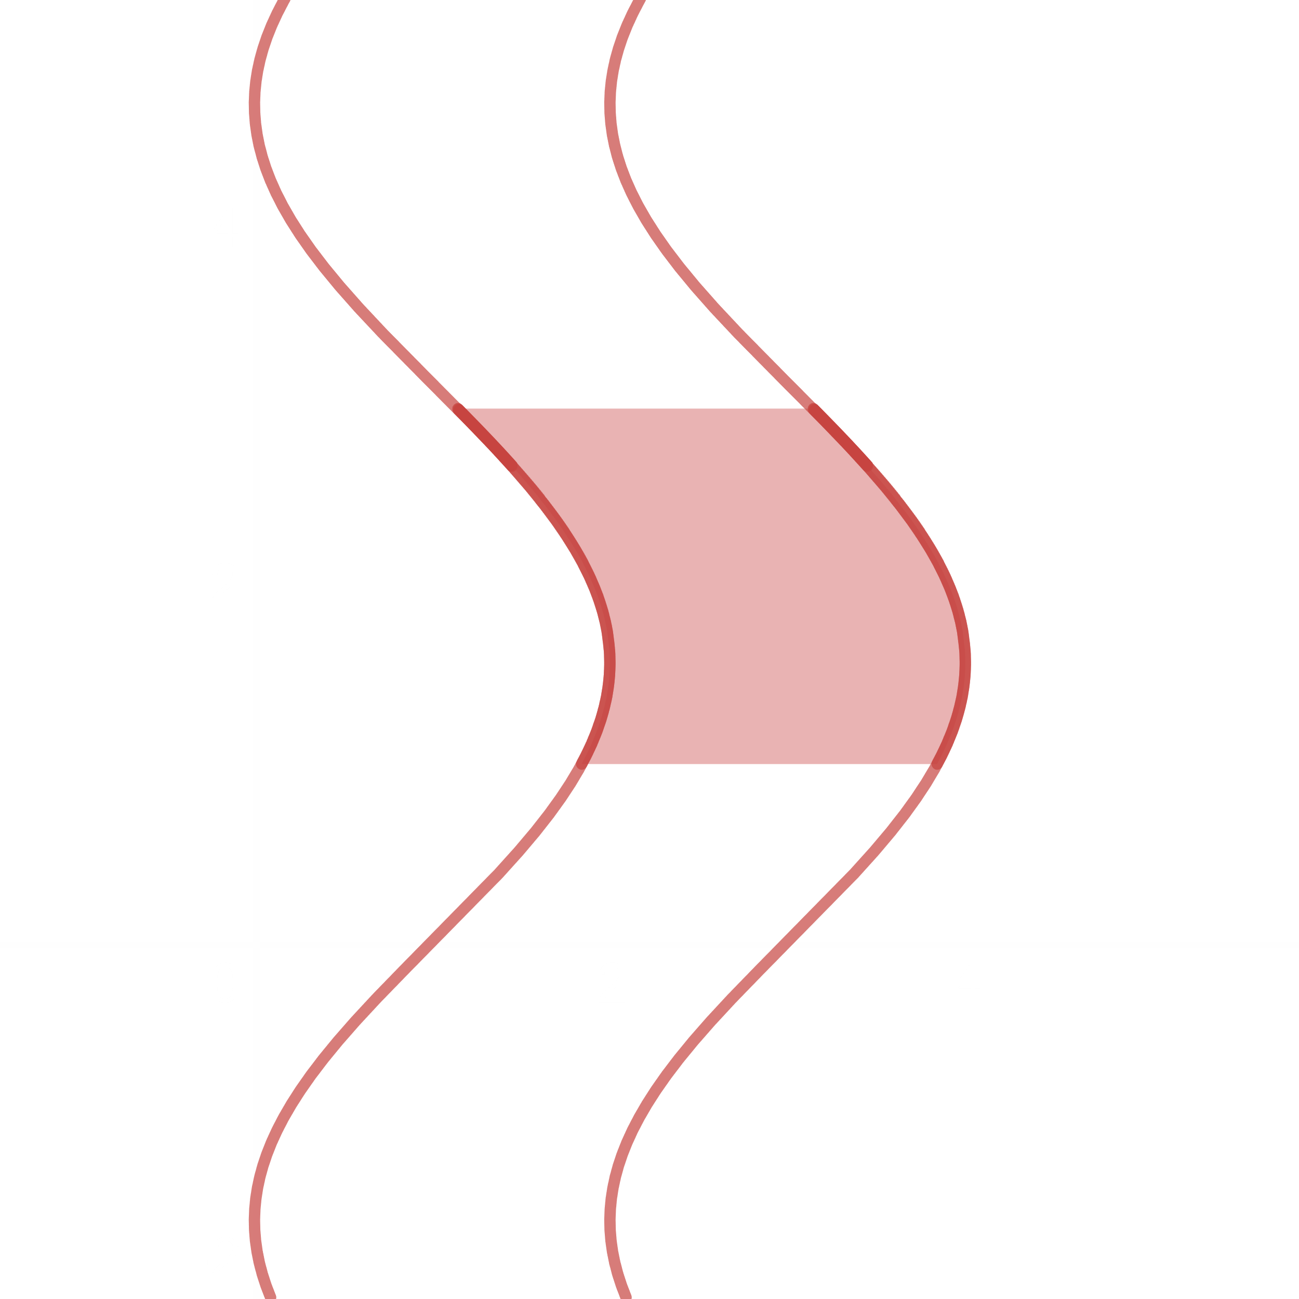

$$A=\int_{a}^{b}{\left[g\left(y\right)-f\left(y\right)\right]dy}$$

Example 4: Find the area of the region bounded above by the curve $y=2e^{-x}+x$, below by the curve $y=\frac{e^{x}}{2}$, on the left by $x=0$ and on the right by $x=1$.

Area $=\int_{0}^{1}{\left(2e^{-x}+x-\frac{e^{x}}{2}\right)dx}={\left[-2e^{-x}+\frac{x^{2}}{2}-\frac{1}{2}e^{x}\right]}_{0}^{1}=-\frac{2}{e}+\frac{1}{2}-\frac{1}{2}e+2+\frac{1}{2}$

Area $=\left(3-\frac{e}{2}-\frac{2}{e}\right) units^{2}$

N.B.: If the upper curve and lower curve are not mentioned, the must be found graphically and mentioned in the answer.

Example 5: Find the area of the region enclosed by the parabola $y=2-x^{2}$ and the line $y=-x$.

Given, $y=2-x^{2}$– (i) and $y=-x$– (ii), the limits of integration are obtained by solving (i) and (ii).

$$2-x^{2}=-x$$

$$x^{2}-x-2=0$$

$$x=-1, 2$$

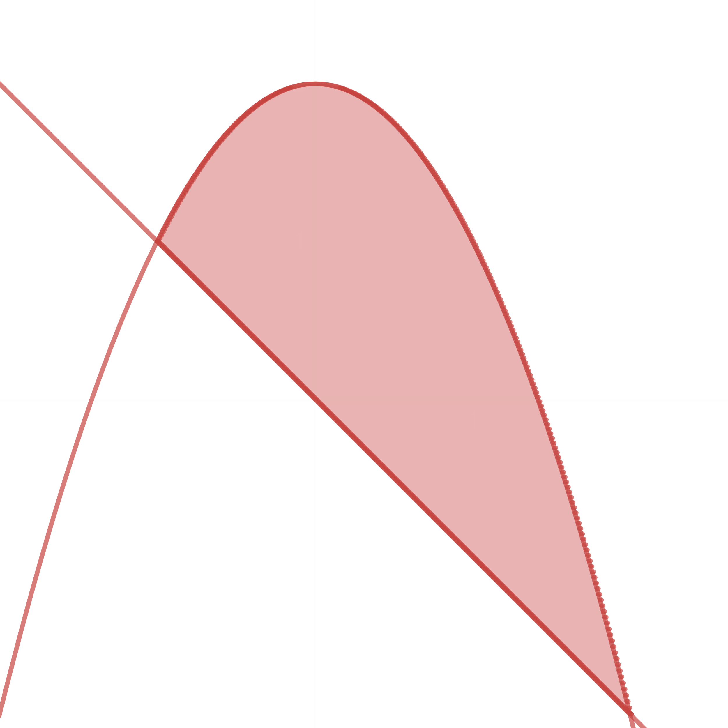

The region is bounded above by the parabola $y=2-x^{2}$, below by the line $y=-x$, on the left by $x=-1$ and on the right by $x=2$.

Area $=\int_{-1}^{2}{\left(2-x^{2}+x\right)dx}={\left[2x-\frac{x^{3}}{3}+\frac{x^{2}}{2}\right]}_{-1}^{2}=4-\frac{8}{3}+\frac{4}{2}-2-\frac{1}{3}-\frac{1}{2}=0.5 units^{2}$

Example 6: Find the area of the region bounded by the parabola $y=\sqrt{x}$ and the line $y=x-2$

$$\sqrt{x}=x-2$$

$$x={\left(x-2\right)}^{2}$$

$$x=1, 4$$

$$\sqrt{1}≠1-2$$

$$∴x=4$$

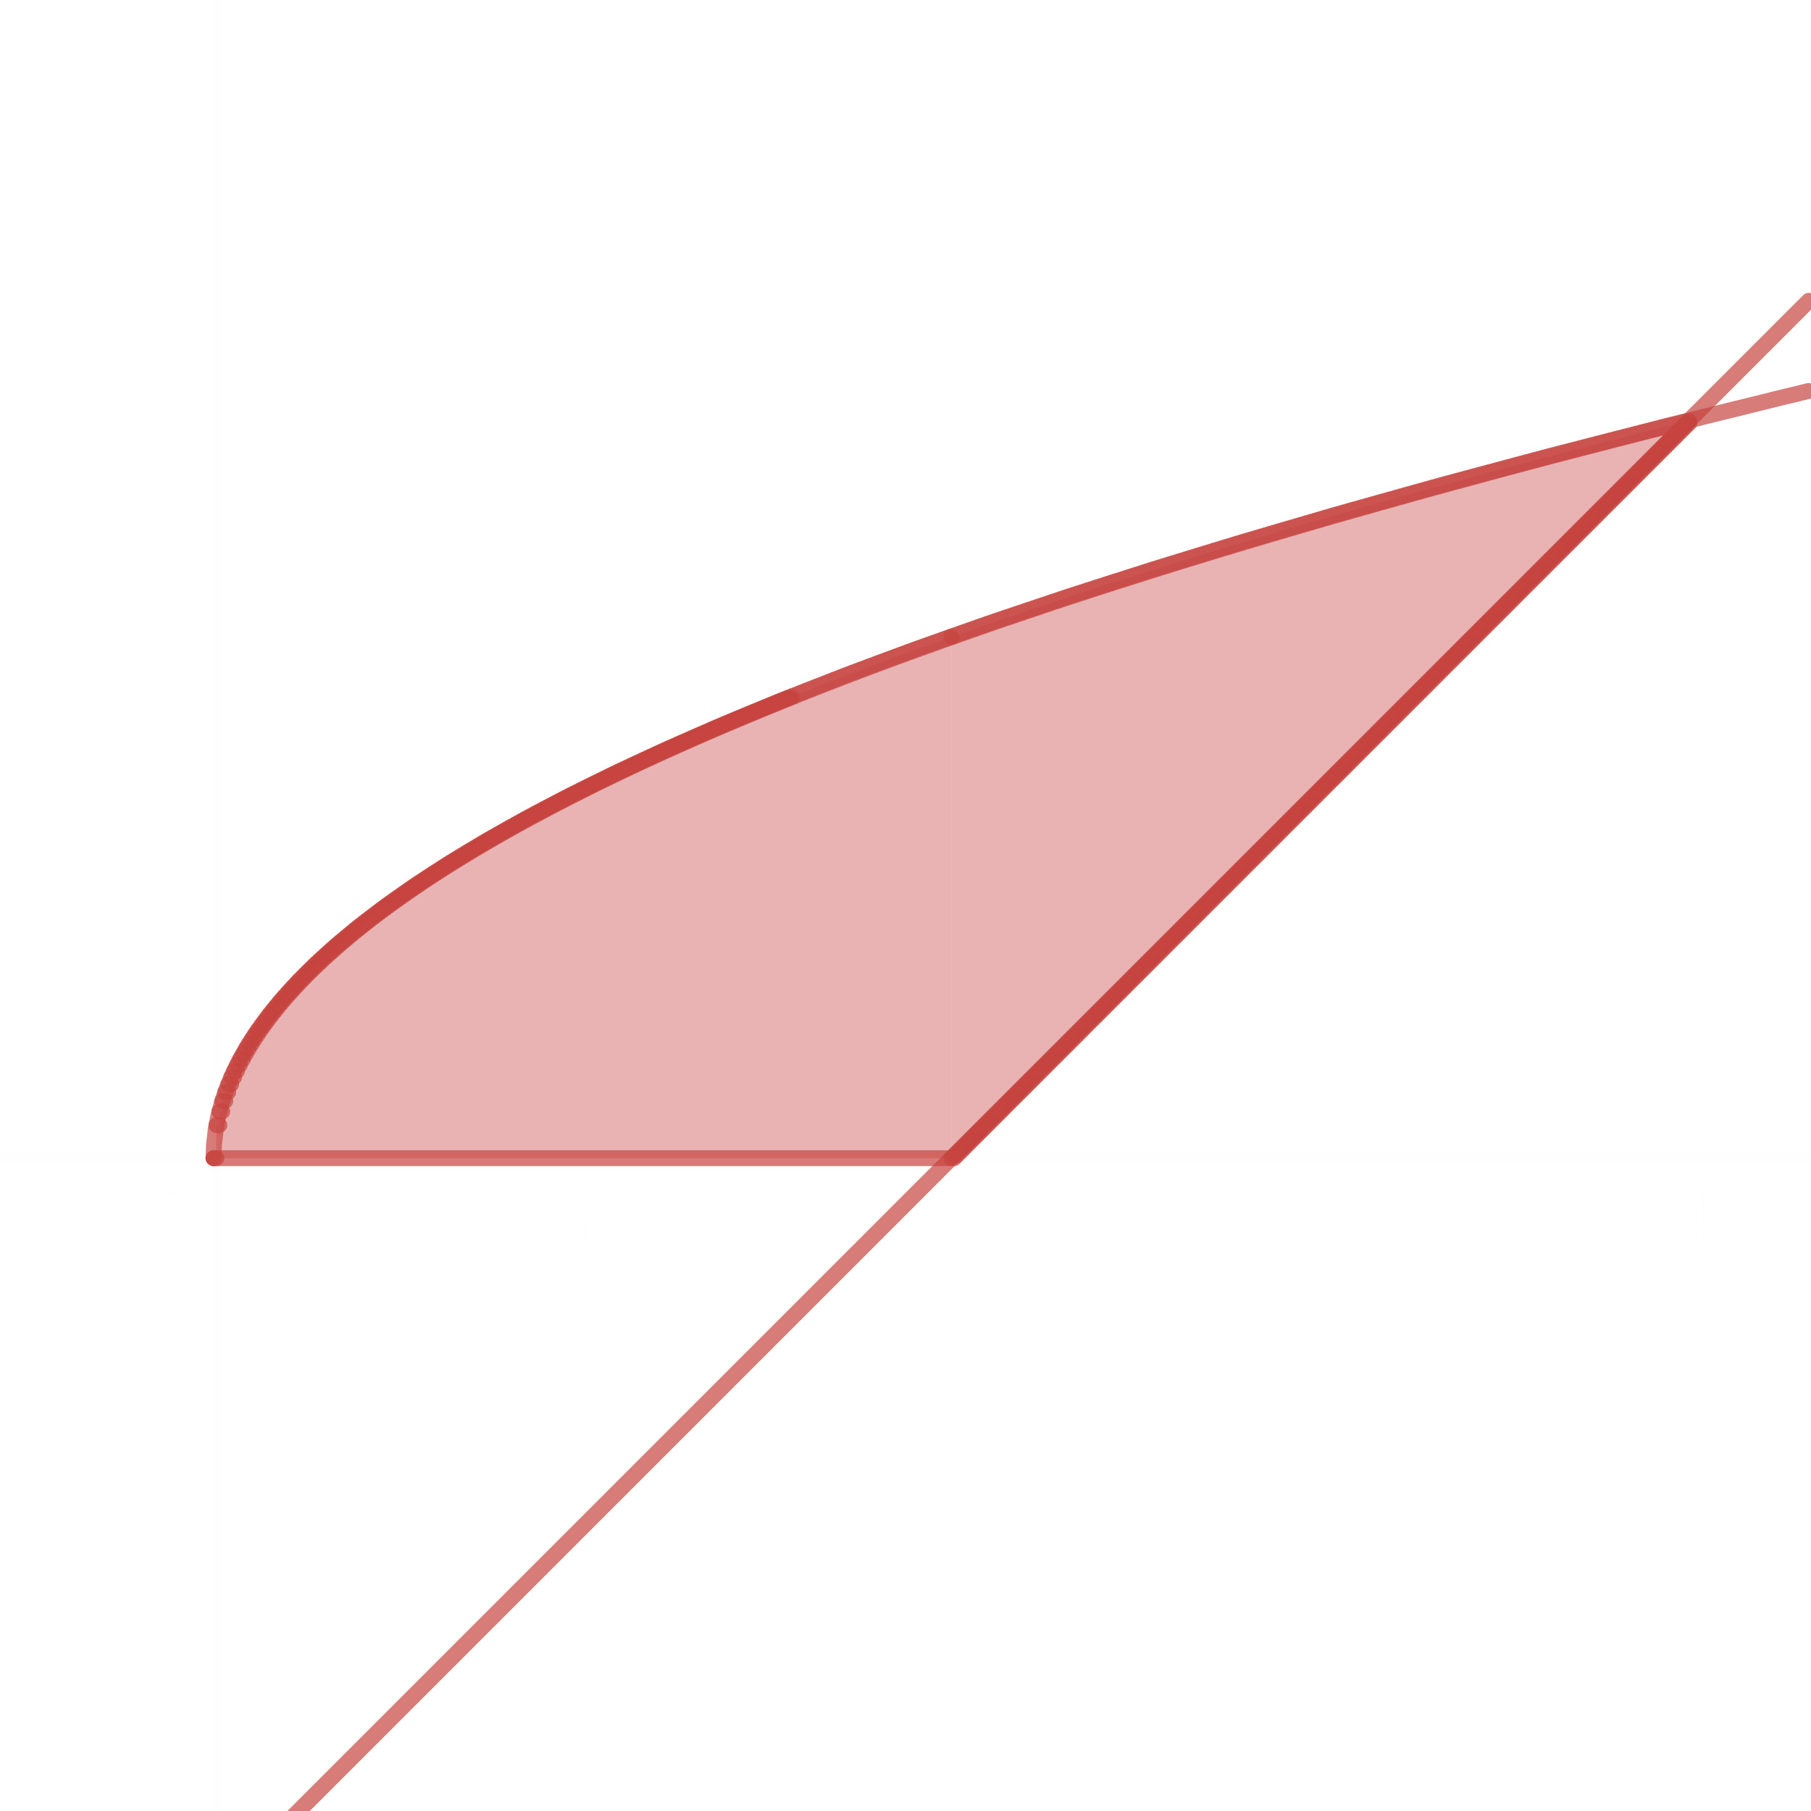

Area $=\int_{0}^{2}{\sqrt{x}dx}+\int_{2}^{4}{\left(\sqrt{x}-x+2\right)dx}={\left[\frac{2x^{\frac{3}{2}}}{3}\right]}_{0}^{2}+{\left[\frac{2x^{\frac{3}{2}}}{3}-\frac{x^{2}}{2}+2x\right]}_{2}^{4}$

Area $=\left(\frac{2}{3}×2^{1.5}\right)+\left(\frac{2}{3}×4^{1.5}\right)-8+8-\left(\frac{2}{3}×2^{1.5}\right)+2-4=\frac{10}{3}units^{2}$

Exercise 5.6

1 – 46

Evaluate

2. b)

Let .

is an odd function.

$$\int_{-a}^{a}{f\left(x\right)dx}=0$$

$$∴\int_{-1}^{1}{x\sqrt{1-x^{2}}dx}=0$$

OR

$\int_{0}^{0}{-\frac{1}{2}\sqrt{z}dz}=0$ since $\int_{a}^{a}{f\left(x\right)dx}=0$

Exercise 16

$$\int_{1}^{4}{\frac{dy}{2\sqrt{y}{\left(1+\sqrt{y}\right)}^{2}}}$$

Let $x=1+\sqrt{y}$

$$dx=\frac{1}{2\sqrt{y}}dy$$

$y=4$ $x=3$

$y=1$ $x=2$

$$\int_{1}^{4}{\frac{dy}{2\sqrt{y}{\left(1+\sqrt{y}\right)}^{2}}}$$

$$=\int_{2}^{3}{\frac{1}{x^{2}}dx}$$

$$={\left[-\frac{1}{x}\right]}_{2}^{3}$$

$$=\frac{1}{2}-\frac{1}{3}$$

$$=\frac{1}{6}$$

Exercise 39

$$\int_{0}^{\ln{\sqrt{3}}}{\frac{e^{x}}{1+e^{2x}}dx}$$

Let $z=1+e^{2x}$

$$dz=2e^{2x}dx$$

$$\frac{1}{2e^{2}}dz=e^{x}dx$$

$x=0$ $z=2$

$x=\ln{\sqrt{3}}$ $z=4$

$$\int_{0}^{\ln{\sqrt{3}}}{\frac{e^{x}}{1+e^{2x}}dx}$$

$$=\int_{2}^{4}{\frac{1}{2e^{2}z}dz}$$

$$=\frac{1}{2e^{2}}{\left[\ln{z}\right]}_{2}^{4}$$

$$=\frac{\ln\left(\frac{4}{2}\right)}{2e^{2}}$$

Exercise 63 – 70

Find the area of the region enclosed by the lines of the curves:

Exercise 63.

$y=x^{2}-2$ and $y=2$

$$2=x^{2}-2$$

$$x=±2$$

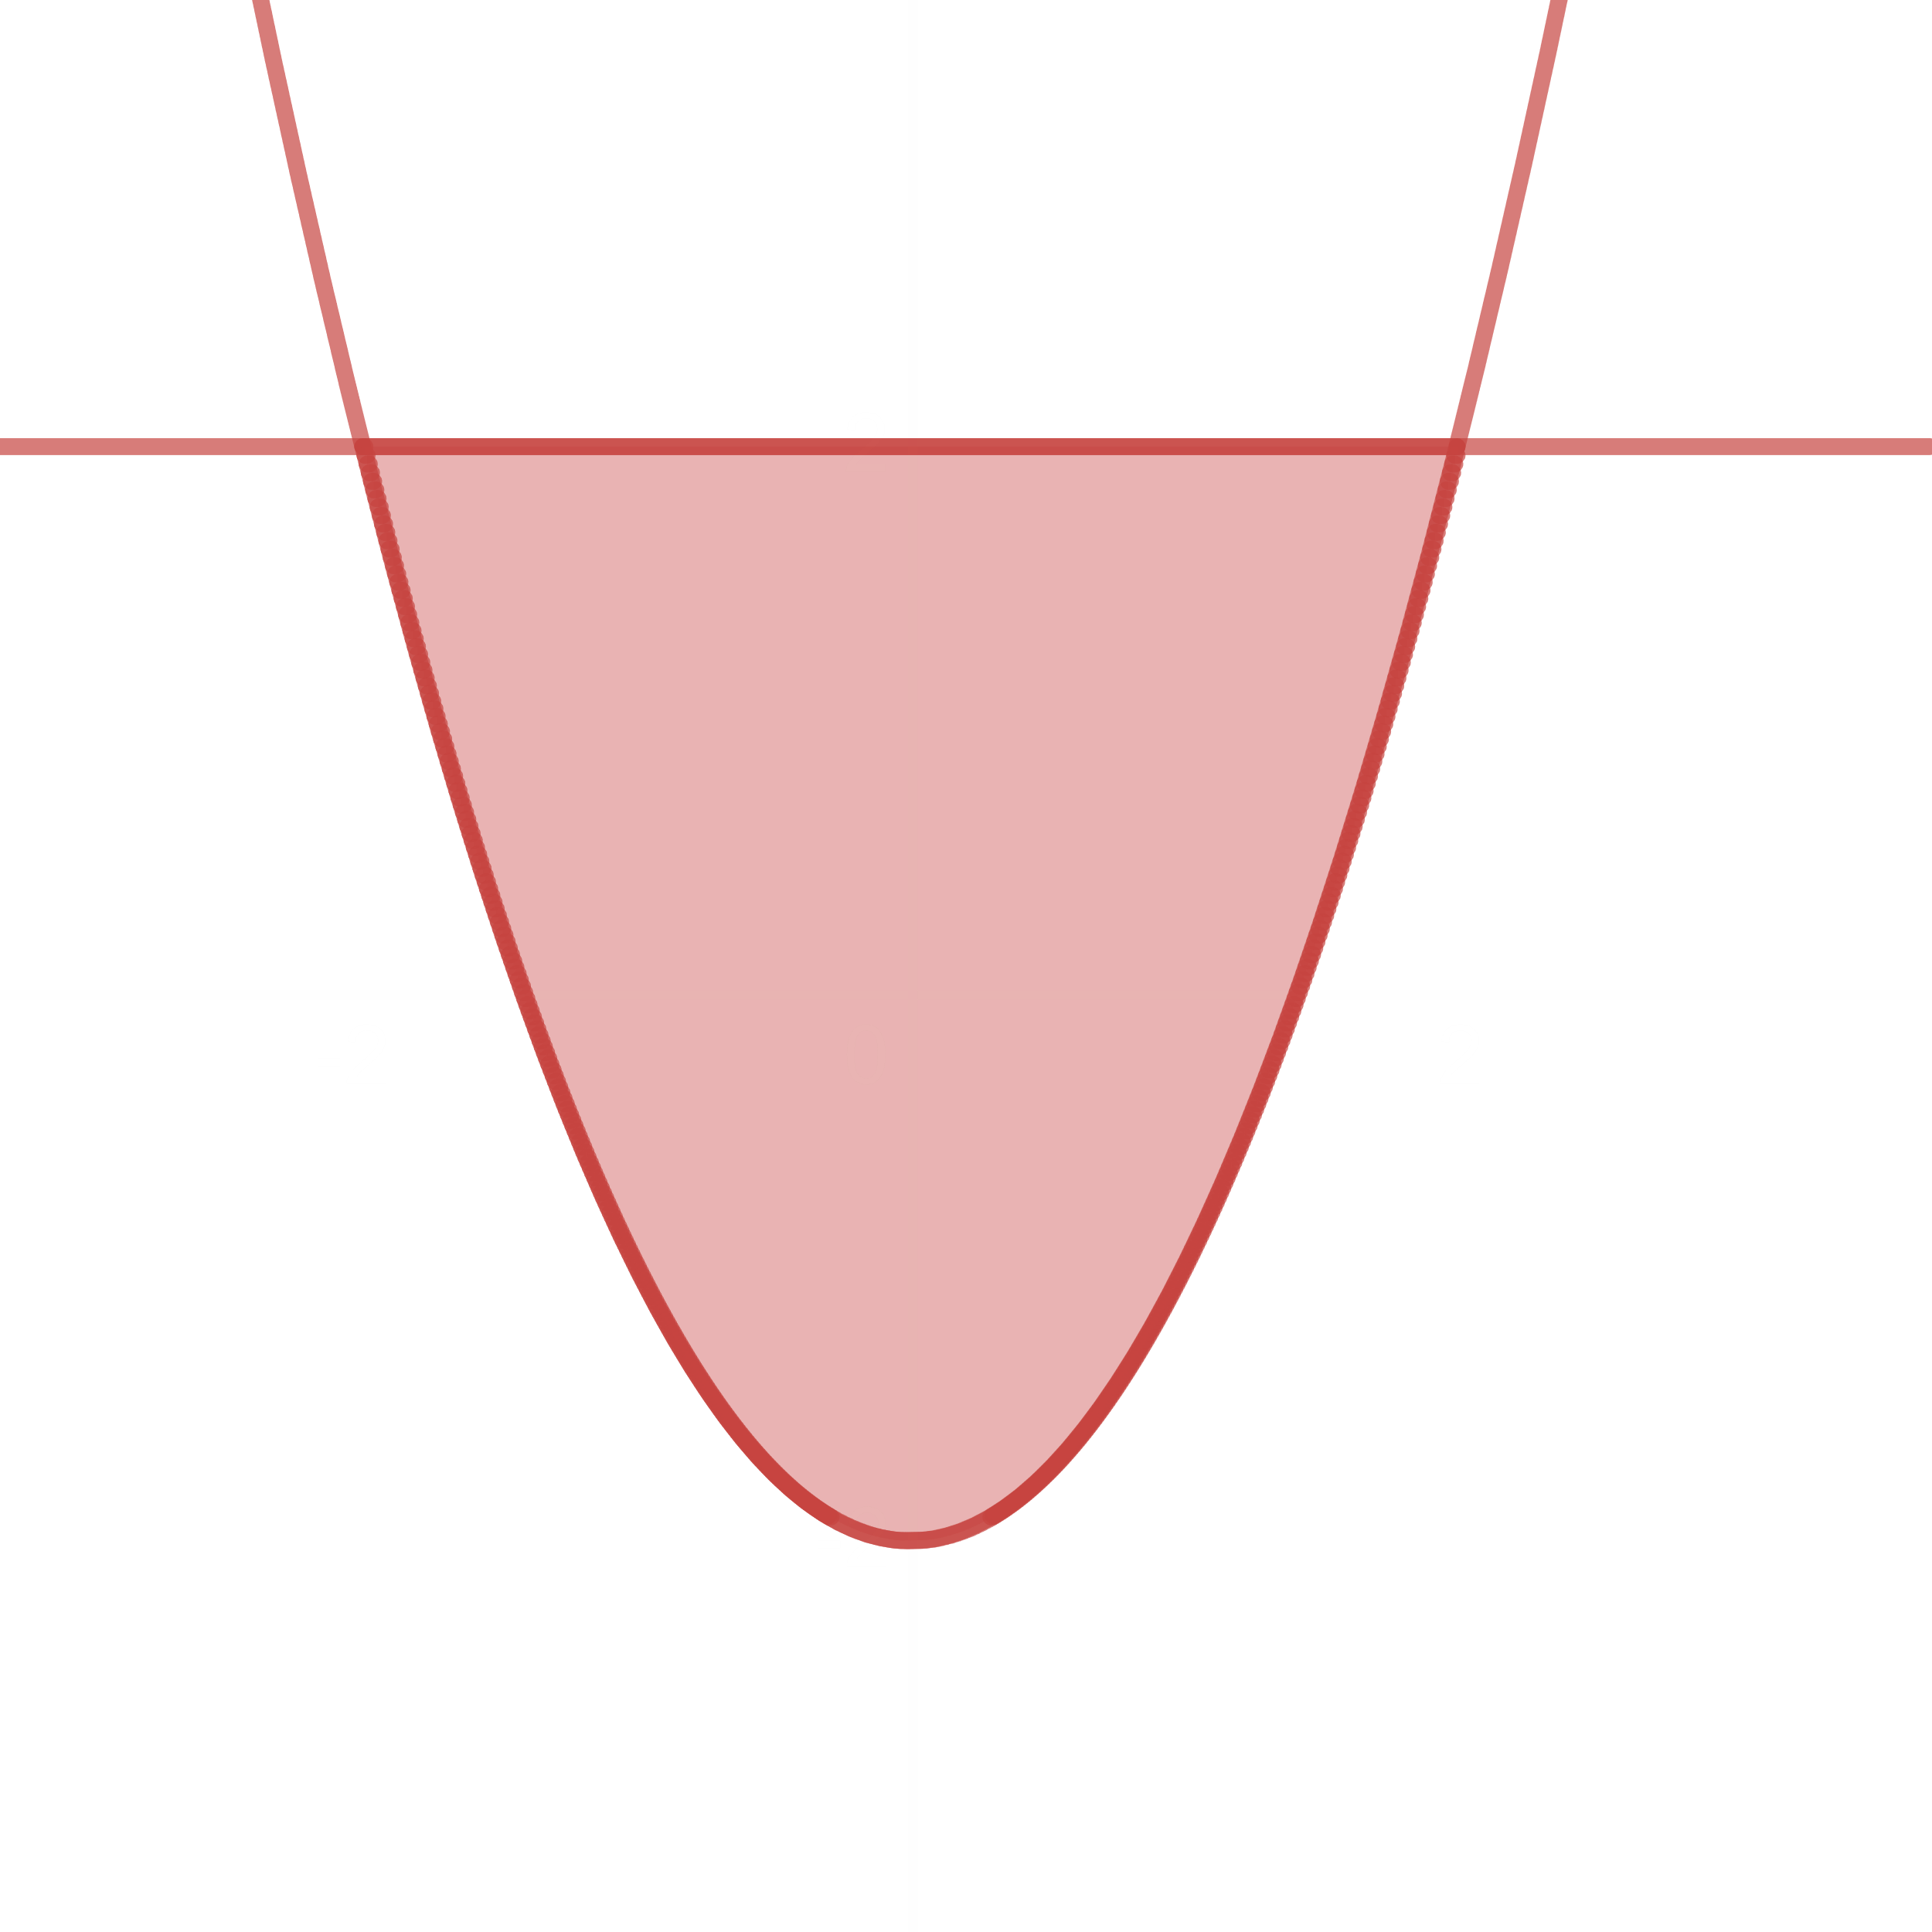

The area is bounded above by the lines $y=2$, below by the curve $y=x^{2}-2$, on the left by $x=-2$ and on the right by $x=2$.

Area $=\int_{-2}^{2}{\left(2-x^{2}+2\right)dx}$

$$={\left[4x-\frac{x^{3}}{2}\right]}_{-2}^{2}$$

$$=8-\frac{8}{3}+8-\frac{8}{3}$$

$$=\frac{32}{8}units^{2}$$

Exercise 68

$y=7-2x^{2}$ and $y=x^{2}+4$

$$7-2x^{2}=x^{2}+4$$

$$x=±1$$

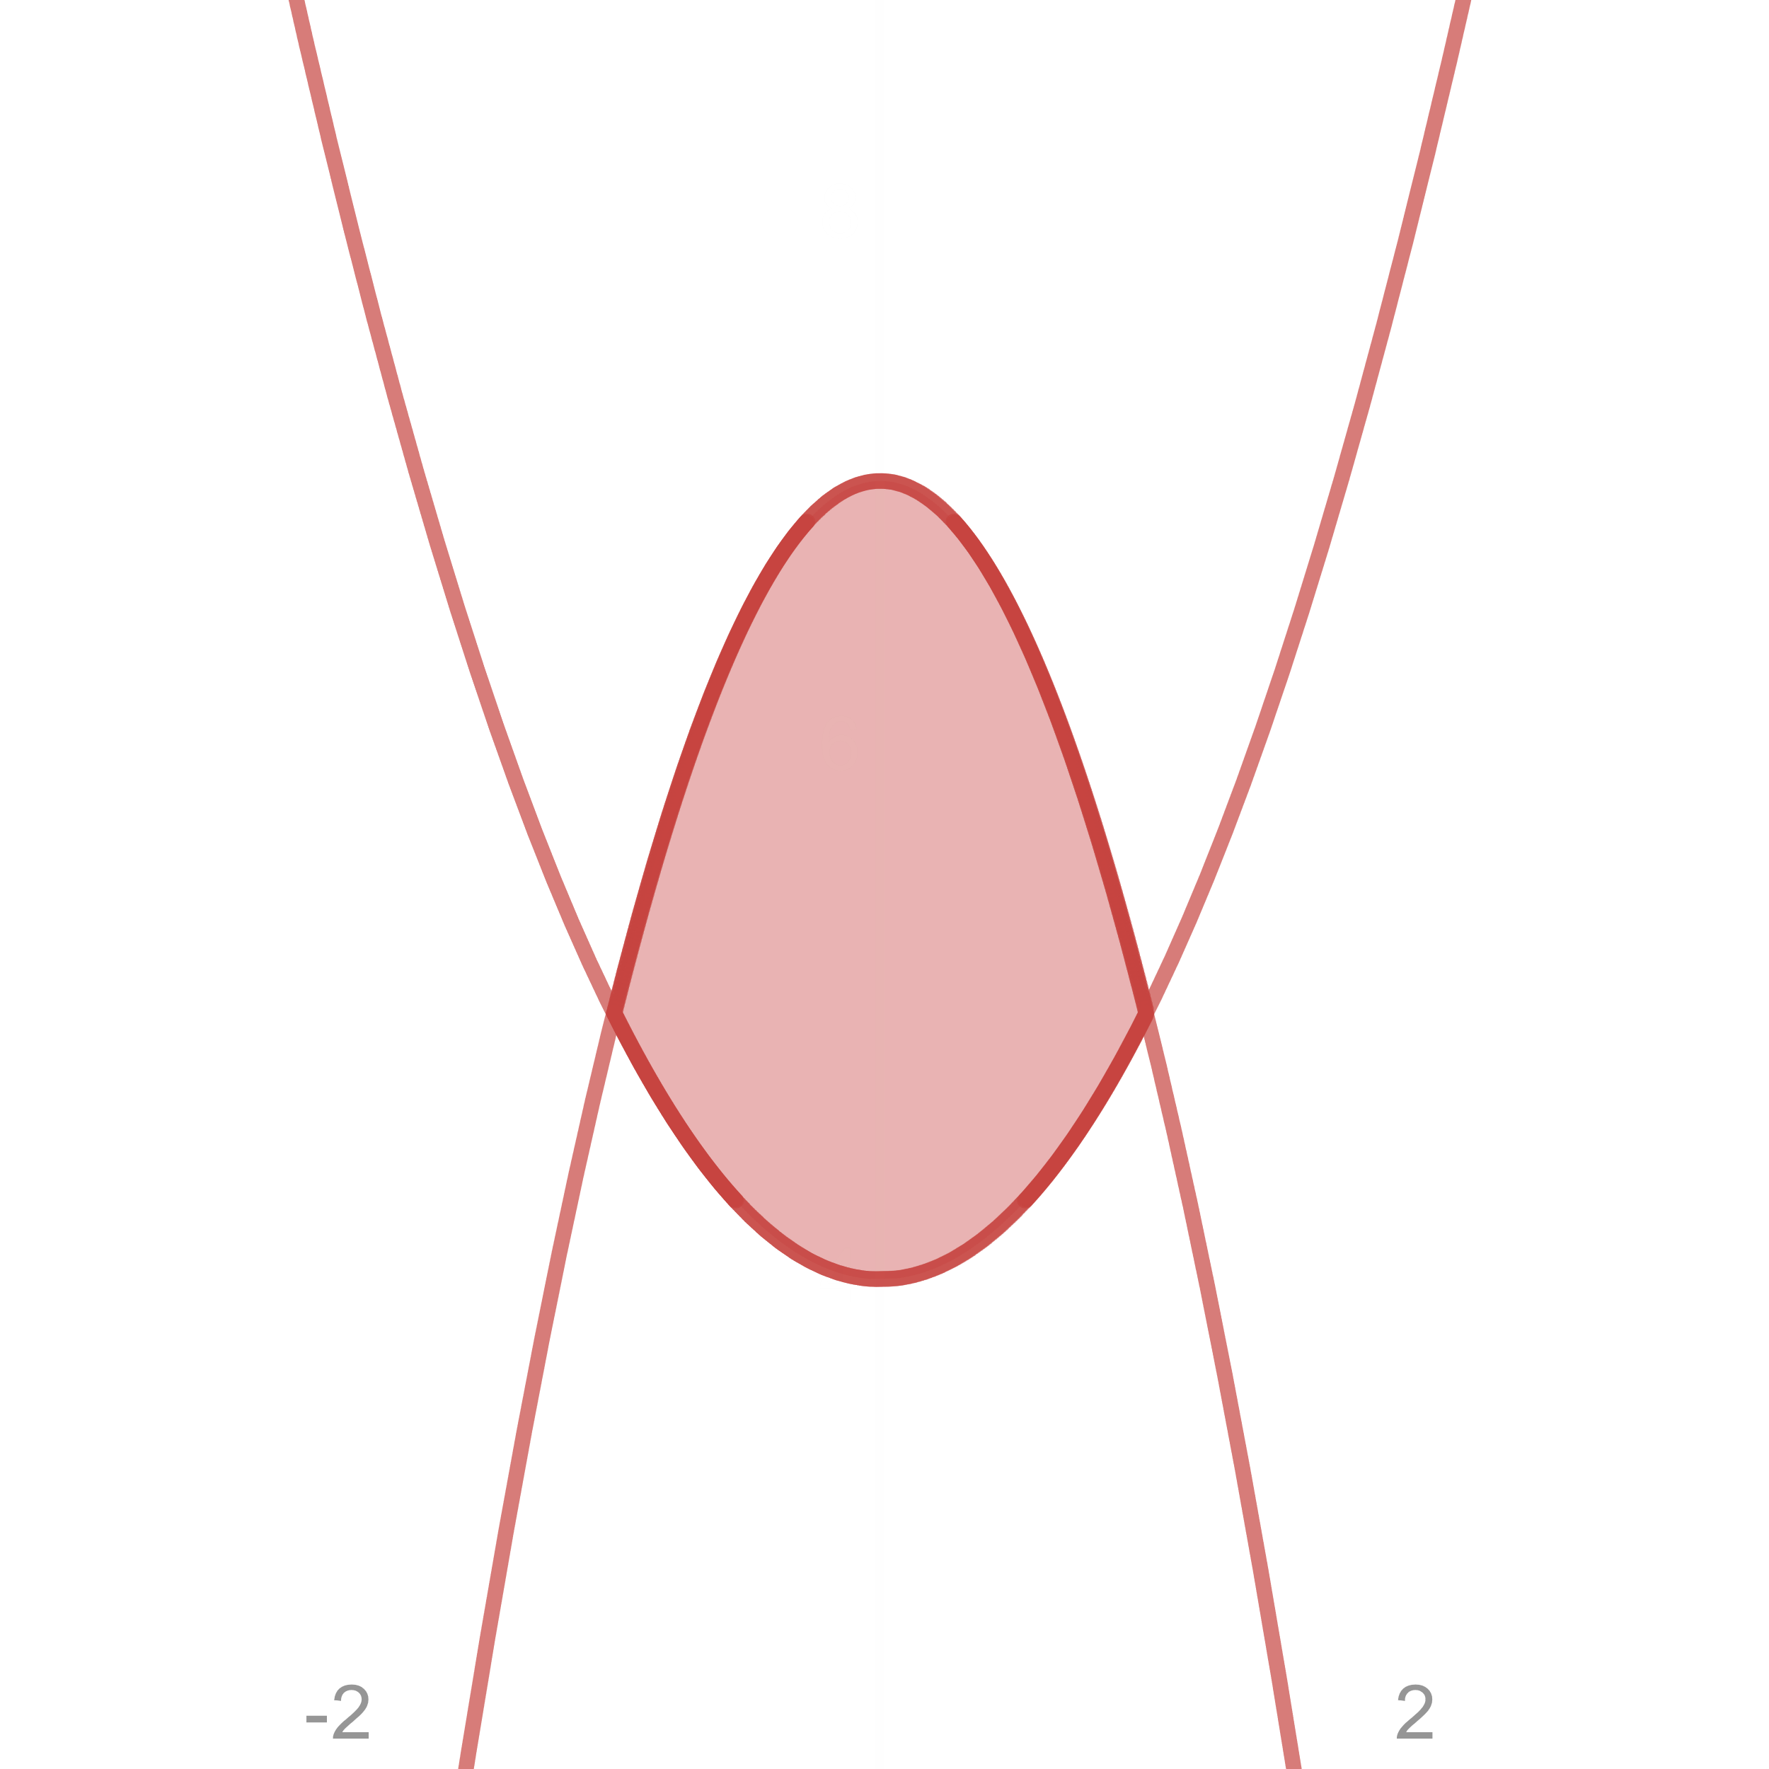

The area is bounded above by the curve $y=7-2x^{2}$, below by the curve $y=x^{2}+4$, on the left by $x=-1$ and on the right by $x=1$.

Area $=\int_{-1}^{1}{\left\{\left(7-2x^{2}\right)-\left(x^{2}+4\right)\right\}dx}$

$$={\left[3x-x^{3}\right]}_{-1}^{1}$$

$$=3-1+3-1$$

$$=4 units^{2}$$